BLUETTI to Debut its Latest EP900 Home Power Backup System at CES 2023

BLUETTI, a pioneer in the clean energy storage industry, has decided to showcase its new model EP900 and other power backup products at the upcoming CES 2023, the world’s biggest tech conference. It claims to redefine home energy at Las Vegas Convention Center, North Hall #9335, January 5-8, 2023.
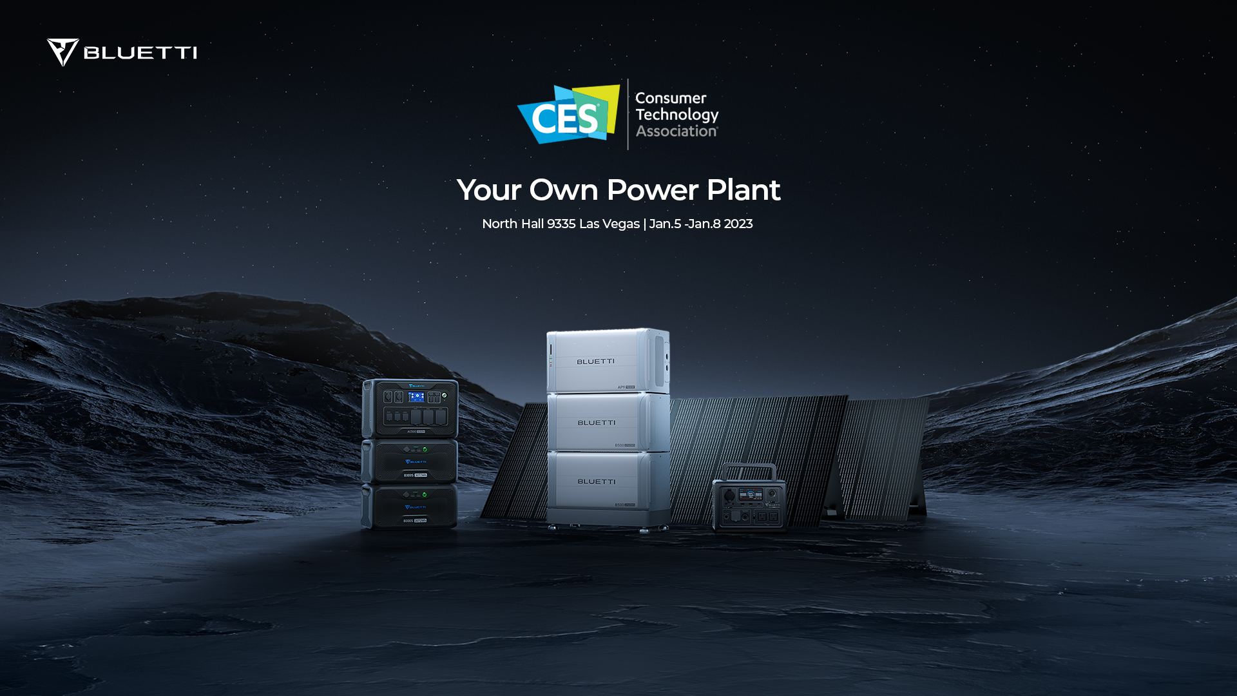

EP900+B500 - Modular Energy Storage System for Whole House
The upgraded EP900 & B500 features a 9kW inverter and expandable capacity that starts at 9kWh with a single B500 LFP battery and ends at 79kWh when paired with 16 batteries. The system can be integrated directly into any solar system, allowing for 9kW max solar input. Besides its peak-load shifting mode to reduce electric bills, it also acts as an uninterruptible power supply (UPS) that switches instantly to battery power in 10ms after the grid power fails. Easy installation (no wall mounting needed) and flexibility make it a comparable or even better alternative to the Tesla Powerwall.

AC500+B300S - Modular Energy Storage System for All Occasions
The stellar combo of the year will also hit the stage. A month earlier, it raised $11 million from more than 4,000 backers on Indiegogo, another record in BLUETTI's history.
The 16-outlet solar generator pumps out 5kW pure sine wave power and can be charged via 8kW AC+ Solar dual input. The AC500 can handle anything from home blackouts to outdoor camping when teamed with one to six B300S LFP batteries for a maximum capacity of 18,432Wh.

Other Power Generator Selection
BLUETTI has a diverse product range that can be classified by size, usage, or design. It has a lineup of portable generators called the EB series, such as the popular 10-pound EB3A. The AC200MAX, AC200P and EP500, EP500Pro make up the best all-in-one power giant collection. Options for power stations are growing in number as BLUETTI's R&D team continues to roll out products based on customer demand.

About BLUETTI
With over 10 years of industry experience, BLUETTI has tried to stay true to a sustainable future through green energy storage solutions for both indoor and outdoor use while delivering an exceptional eco-friendly experience for everyone and the world. BLUETTI is making its presence in 70+ countries and is trusted by millions of customers across the globe. For more information, please visit BLUETTI online at https://www.bluettipower.com/

Or follow us on social media:
Facebook: https://www.facebook.com/bluetti.inc
Instagram: https://www.instagram.com/bluetti_official/
Twitter: https://twitter.com/bluetti_inc
Youtube: https://www.youtube.com/@BLUETTIOfficial

