BLUETTI Named As CES 2023 Innovation Awards Honoree
Las Vegas, NV, BLUETTI 2022 -- BLUETTI today announced that it has been named a CES® 2023 Innovation Awards Honoree for AC500 solar generator. This year’s CES Innovation Awards program received a record high number of over 2100 submissions. The announcement was made ahead of CES 2023, the world’s most influential technology event, happening Jan. 5-8 in Las Vegas, NV.
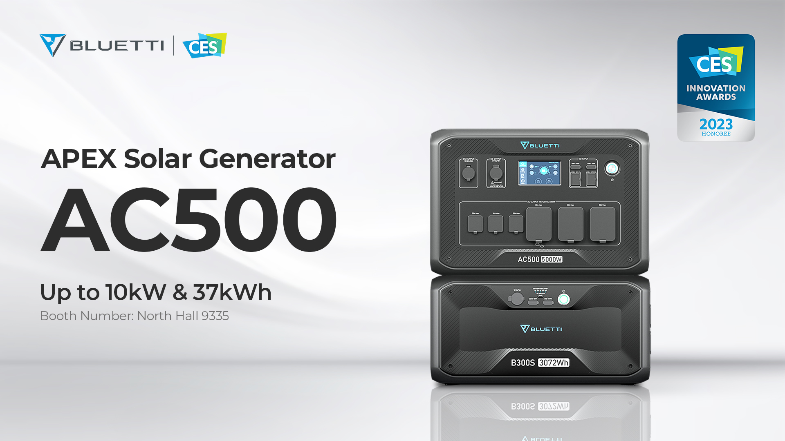

The CES Innovation Awards program, owned and produced by the Consumer Technology Association (CTA)®, is an annual competition honoring outstanding design and engineering in 28 consumer technology product categories. Those with the highest rating receive the “Best of Innovation” distinction. An elite panel of industry expert judges, including members of the media, designers, engineers and more, reviewed submissions based on innovation, engineering and functionality, aesthetic and design.

BLUETTI modular AC500 is compatible with B300S batteries for up to 18,432Wh capacity. Built-in BMS and LFP battery to ensure higher security and longer lifespan. The 5,000W inverter (10,000W surge) allows AC500 to run high-powered electronics without any fuss. Connecting two AC500s in series can double the capacity, voltage, and power to 36,864Wh, 240V/6,000W for a worry-free off-grid living!

It’s encouraging to win the award, which will also inspire us to roll out more innovations to meet the ever-changing power demand in the future. Said James Ray, BLUETTI’s Marketing Director.

New for CES 2023 — CES has partnered with the World Academy of Art and Science (WAAS) to showcase the critical role of technology in support of the United Nations efforts to advance human security around the world. For CES 2023, CTA introduced a new category of Innovation Awards showcasing technologies advancing human rights. The Human Security for All category includes eight new tech subcategories.

The CES 2023 Innovation Awards honorees, including product descriptions and photos, can be found at CES.tech/innovation. More will be revealed in January. Many honorees will showcase their winning products in the Innovation Awards Showcase at CES 2023.

Owned and produced by CTA, CES 2023 will take place in Las Vegas on January 5-8, 2023, with Media Days taking place January 3-4, 2023. Attendees will experience new technologies from global brands, hear about the future of technology from thought leaders and collaborate face-to-face with other attendees. The show will highlight how innovations in sustainability, transportation and mobility, digital health, the metaverse and more are addressing the world’s greatest challenges. Audiences will hear from industry experts during live keynotes, including leaders from John Deere and AMD. Visit CES.tech for all CES 2023 updates, registration details and the media page for all press resources.

About BLUETTI
With over 10 years of industry experience, BLUETTI has tried to stay true to a sustainable future through green energy storage solutions for both indoor and outdoor use while delivering an exceptional eco-friendly experience for everyone and the world. BLUETTI is making its presence in 70+ countries and is trusted by millions of customers across the globe. For more information, please visit BLUETTI online at https://www.bluettipower.com/.

