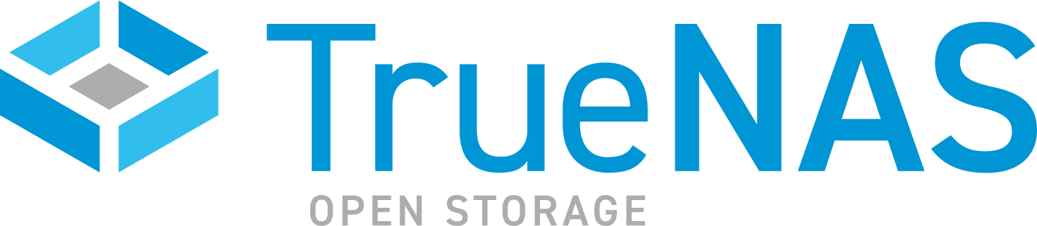

PRESS RELEASE
FOR IMMEDIATE RELEASE

iXsystems Introduces TrueNAS Hybrid Cloud SaaS for MSPs

TrueCommand Cloud enables delivery of managed TrueNAS services across hybrid cloud deployments

SAN JOSE, CA – December 15, 2020 -- The TrueNAS Open Storage portfolio was expanded today with the addition of TrueCommand™ Cloud – a cloud-based service to simplify 24x365 TrueNAS management. As a major upgrade to the iXsystems Channel Partner Program, the cloud-based management software for TrueNAS deployments enables revenue producing services for partners moving into managed storage service delivery. The solution lowers operational costs and improves productivity through increased asset utilization, system optimization, real-time system monitoring, on-demand provisioning, and more.

TrueNAS embraces the need for flexible Hybrid Cloud deployments. In addition to TrueCommand Cloud, TrueNAS can use Cloud storage services (S3, Backblaze, Azure, and many others) and be deployed as cloud instances (AWS, Azure, VMware). Data can be backed up or synchronized between Cloud and cost-effective on-premises TrueNAS systems, such as the X, R, and M-Series. TrueNAS CORE instances can be deployed on AWS and managed via the same TrueCommand Cloud service. In early 2021, TrueNAS SCALE instances will be available for scale-out deployments. TrueCommand Cloud will also act as the management platform for these Hybrid Cloud deployments.

TrueCommand Cloud extends the TrueCommand single pane of glass management software to a SaaS model with an integrated VPN capability that can traverse the Internet. The solution is optimized for MSP and channel enablement with management of many customers’ systems, plus:
- Multi-system management from a single Web console
- ZFS-aware monitoring, alerting, and reporting
- Cluster management and multi-tenancy
- Fault management with team-based trouble ticketing
- Role Based Access Control (RBAC) with Active Directory integration
- Configuration auditing

TrueCommand manages TrueNAS CORE, Enterprise, and SCALE instances and can be used by MSPs, Enterprises, smaller organizations, and other TrueNAS users.

TrueCommand Cloud leads a major upgrade to the iXsystems Channel Partner Program, which also includes:
- Deal registration, Partner activity management, and resource portal
- Specialized technical and sales training for partners
- Reciprocal lead generation through the TrueNAS Open Storage Community
- Product demonstrations and Sales Engineering support
- Tiered pricing discounts and SPIFFs for registered deals
- MSP enablement with TrueCommand Cloud management

"Cloud solutions and services have taken center stage and increasingly, traditional VARs and resellers plan to make the move to managed services and capture the surge in demand," said Kevin Rhone, Senior Partnering Consultant for Channel Acceleration with the Enterprise Strategy Group (ESG). "With TrueCommand Cloud, iXsystems is simplifying this shift with what is essentially a cost-effective virtual network operations center (NOC). Empowered with the right tools for remote supervision, monitoring and maintenance of local, hybrid and cloud-based enterprise storage, service providers can better manage storage services and efficiently support their cloud services customers."

"The lines between VARs and MSPs are blurring. TrueCommand Cloud is foundational in the support of channel partners to deliver the industry's most powerful and value-added storage services on the market," said Morgan Littlewood, SVP, Product Management and Business Development. "We invite both current and new partners to learn more about the iXsystems Channel Partner Program and TrueCommand Cloud service enablement platform."

TrueCommand Cloud is available immediately to customers, users, and partners, and can be activated via a self-service portal. Subscriptions start at $10 per month for managing up to 50 drives. TrueCommand software can also be deployed as Docker instances or VMs and is available for free for less than 50 drives.

To learn more about how TrueNAS can help your organization, contact us via https://www.truenas.com/contact-us/, or give us a call at 1-855-GREP-4-IX.

Tweet This: @ iXsystems introduces TrueCommand Cloud: management for TrueNAS fleets & hybrid clouds- https://www.ixsystems.com/press-releases/

Additional Resources:
● To learn more about TrueNAS Open Storage, visit: https://www.truenas.com
● Follow TrueNAS News on Twitter at: http://twitter.com/iXsystems

About iXsystems and TrueNAS
Through decades of expertise in system design and development of Open Source software (FreeNAS, FreeBSD, OpenZFS, and TrueNAS), iXsystems has become an innovation leader in high availability storage and servers powered by Open Source solutions. With over one million deployments and backed by the legendary ZFS file system, TrueNAS offers the stability and reliability required for Backup, Multimedia, Cloud Hosting, Virtualization, Hyper-converged Infrastructure, and much more. Since the founding of iXsystems in 2002, thousands of companies, universities, and government organizations have come to rely on the company’s enterprise servers, TrueNAS Open Storage, and consultative approach to building IT infrastructure and Private Clouds with Open Source economics.

- END -

