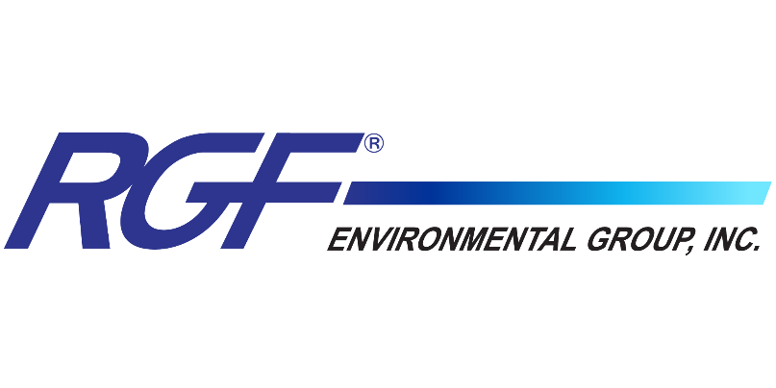
FOR IMMEDIATE RELEASE

RGF® Environmental Group Focuses on “Clean Air Is Life, Let Us Help Protect Yours”- Raises Bar for Residential and Commercial HVAC Indoor Air Quality
Here’s an inside look at how RGF® is bringing HVAC into a new era with its products and focus on indoor air protection. Learn about its state-of-the-art product offerings in this newly released campaign.
Port of Palm Beach, FL (November 09, 2021) As the leader in innovative solutions to indoor air quality problems, it's no surprise that RGF® has taken air purification to the next level. Introducing an opportunity to innovate, educate and lead the HVAC industry into a new era while providing homeowners with proactive indoor air treatment.

RGF® is dedicated to the pursuit of clean indoor air, something that has been the driving force behind each and every innovation over its thirty-five year history. Making premium, award-winning products that integrate into the HVAC system, with continuous ‘no-touch’ operation and whole home treatment embodies RGF’s innovation. RGF® manufacturers products utilizing best in-class air purification technologies like its proprietary PHI-CELL®, Lucidium® UV-C lights and Microcon® HEPA filters. RGF® indoor air quality systems are available to fit every application and are proven effective at reducing bacteria, mold spores, viruses and odors to consistently create the freshest air in your home or business.

Key elements of the “Clean Air is Life” campaign include:

- Navigate the Indoor Air Quality Market Place. RGF® Environmental with its long history as a manufacturer of indoor air quality (IAQ) devices sought to demonstrate the effectiveness of its patented Photohydroionization® technology (PHI CELL®) for controlling SARS-CoV-2 and a variety of other airborne pollutants in at-risk environments.
- Increased Production for Worldwide Demand. With worldwide demand for RGF’s air sanitizing
solutions, RGF’s two Florida-based manufacturing plants have increased production capacity by over 400%.

- Worldwide Manufacturing Leadership. With carefully engineered and rigorously tested environmental purification solutions, RGF is leading the industry with high quality products that are made in the USA and distributed in over 80 countries.

"At RGF®, we are committed to building a cleaner world for generations to come. Delivering fresh, clean air is as much of a mission as it is a responsibility. It’s about improving everyday life through innovative environmental solutions that will positively impact the lives of others,” says Mat Charles, Vice President of Airside Products.
“Today’s contractors and homeowners are keenly aware of the importance of indoor air quality,” says RGF® CEO Ron Fink. “Our advancements in both technology and manufacturing methods have allowed us to adapt to the changing markets with great speed. We always have been, and always will be a pioneer and a leader in this industry.”

RGF Environmental is committed to the principle that “Clean Air is Life”. We will continue our efforts to develop innovative IAQ devices and conduct scientific research with leading government, private and academic laboratories to provide documentation on the safety and efficacy of our products.

About RGF® Environmental Group, Inc.

RGF manufactures over 500 environmental products and has a 36+ year history of providing the world with the safest air, water and food without the use of chemicals. RGF is an ISO 9001:2015 certified research and innovation company, holding numerous patents for wastewater treatment systems, air purifying devices, and food sanitation systems. Situated in the heart of the Port of Palm Beach Enterprise Zone, RGF Headquarters span 10 acres, with 200,000 square feet of manufacturing, warehouse and office facilities. RGF’s Lakeland, FL facility adds over 40,000 square feet for back-up production and lamp production. RGF continues to upgrade its facilities, creating an increased vertical approach to manufacturing, further allowing the company to provide the highest quality and best-engineered products on the market. For more information, visit RGF.com.

Media Contact

For more information about RGF® or to schedule an interview, please contact Malia Powers with PowerOn Marketing at malia@poweronmarketing.com or 813-763-7488.

