Out Of Home Technology (OOH) Grabbed Attention of Olympics World Champion
World badminton champion Carolina Marin launched Mea Hoardings multi vendor mobile app, where outdoor companies and agencies can set up their own ooh marketplace to sell vacant billboards online.

Mera Hoardings launched the world’s first Billboard booking mobile App compatible with Android and IOS mobile devices at an international level. Multiple billboard companies and Outdoor Agencies can set up their own marketplace all over the globe at an ease. World badminton champion Ms. Carolina Marin inaugurated Multi-Vendor mobile app at Hyderabad, India; MeraHoardings.com is an Indian Outdoor Advertising online booking company eminent for innovation since 2015.

Pumping up in an Out of Home Advertising industry Mera Hoardings introduced the world’s foremost billboard booking mobile app compatible with Android and IOS mobile devices. The word revolution is a bit overused these days, but it’s fair to say that the possibilities explored by Mera Hoardings. Outdoor Advertising online booking systems are far-reaching. Indian Outdoor Advertising AD-Space’s online booking platform www.merahoardings.com launched in December 2015. It has been increasing tremendous development since its origination and expanding business world-wide. Today Mera Hoardings is the India’s major outdoor promotion online market place company, operating in 20 states with a broad assortment of 30,000+ Billboards/Hoardings across 15000+ diverse vendors. “Mera Hoardings has been an official partner for Sports Championships ranging from Local Cricket leagues to International Cricket. Such as BCCI, IPL, PROKABADDI AND Premier Badminton League. Mera Hoardings has done the most innovative outdoor campaigns in 2017 streamline, this national campaign journey will boosting our team to upgrade this multivendor mobile App technology. “With The Launch We Plan to Go Overall Technology World, Anyone from Any State Can Book a Billboard Anywhere in India, Taking a step further, MeraHoardings.com has clubbed the all Billboards with ‘Hello oOH’ to gauge the traffic movement. The campaign monitoring technology ‘Hello oOH’ gives real-time videos of the advertising site which helps to gauge the impression counts in Mobile APP, Its new trend to out of home (OOH) advertising industry”. Said –Saikrishna Gajavelly , Founder & Chairman Mera Hoardings.

Mera Hoardings world’s first multivendor OOH marketplace mobile app module is easy to setup outdoor companies in their own agency page by sharing their profile and outdoor Media boards on one page, Our Mobile App allows differentiate available billboards from different ooh media agencies. Merahoardings OOH Marketplace will prove to be a one stop solution for Billboard Space buyers who shall be making booking different mediums from different agencies. It is clear that the All Billboard companies and agencies can make their business sales effective by using Multi-Vendor mobile app to set up one’s own marketplace all over the world. This App is very handy for billboard owners and agencies across the globe can easily join and operate their business.

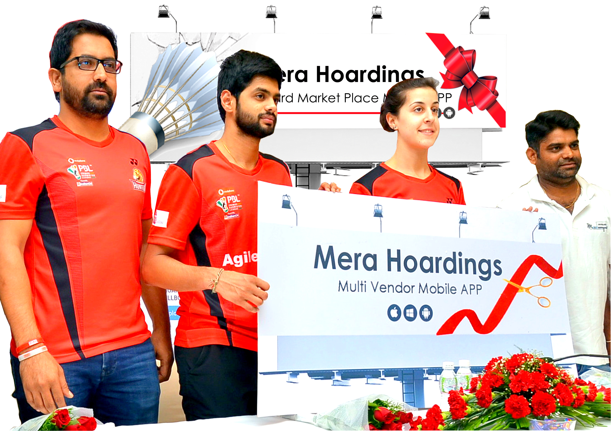
Saikrishna Gajavelly
(Founder of Mera Hoardings)

Carolina Marin
(Olympics Gold medalist & World Badminton Champion)

SaiPraneesh Badminton Player
Vamshi Gurram
(Managment Hyderabad Hunters)
(From Right To Left)
(From Right to left)

"Mera Hoardings is a great concept - it allowed us to hand-select Outdoor advertising space at a very reasonable price in exactly the locations we wanted. All the Best for lunching multi vendor mobile app wishing great success in Out of Home (OOH) industry”. Said – Carolina Marin, world Olympic badminton champion.

