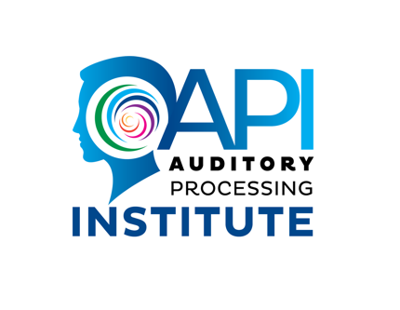

Long COVID “Brain Fog” Linked to Auditory Processing Disorder,
an Underdiagnosed Neurological Disorder

First Study of Its Kind Outlines Symptoms and Uncovers
Proactive Steps Patients Can Take to Get Treatment

FOR IMMEDIATE RELEASE
Contacts: Angela Alexander, +61403700643, angela@apdsupport.com
<< Photos and video with article authors as well as an APD quiz available here >>

Queensland, AU (April 3, 2023)— Long COVID “brain fog” symptoms are linked to auditory processing disorder (APD), an underdiagnosed neurological disorder, suggests a new study from the Auditory Processing Institute of Queensland, Australia scheduled for publication in The Hearing Journal in the April issue. Authored by renowned audiologists Dr. Robert DiSogra and Dr. Angela Loucks Alexander, whose recent TEDx Talk generated more than 1 million views, the study found that patients can be treated effectively with existing interventions. Unfortunately, APD symptoms can easily be confused with other hearing or neurological issues, which is why people with these symptoms should proactively talk to their doctors about getting APD testing.

APD occurs when a patient’s brain has trouble understanding what they hear into usable information in the absence of hearing loss, making it difficult to understand and communicate with others. Untreated patients can quickly suffer serious consequences including inability to connect with others, strained relationships, poor job performance and depression.

“We’ve seen an uptick in patients whose symptoms started after a COVID-19 diagnosis but testing for an auditory processing disorder is rarely recommended. As a result of this study, we can confidently tell people with “brain fog” symptoms to get tested for auditory processing disorder,” says Dr. Angela Loucks Alexander, Director of the Auditory Processing Institute. “Early testing is a simple step that would have saved many of our patients a lot of distress and provided them with treatment much sooner.”

Because “brain fog” symptoms may be caused by a wide variety of neurological and other medical conditions, APD can be overlooked. For patients searching for answers, APD testing could open a new pathway to recovery.

APD patients may experience trouble understanding people when there is background noise, often find that they need information repeated multiple times, cannot understand something that was said after it was repeated to them and might have trouble remembering what was said to them. The good news is that while it is not widely known to the public, auditory processing disorder is both easy to test for and highly treatable.

“This is the first end-to-end scientific case study of its kind evaluating a patient’s diagnosis and progress—providing a road map from diagnosis to recovery. It tells us that existing treatments can have excellent results for patients who are experiencing APD symptoms after COVID-19,” said Dr. Robert DiSogra, an Audiology consultant in Millstone, New Jersey. “We hope to see that more research will occur as a result of this study.”

People experiencing “brain fog” symptoms should take this survey (INSERT LINK TO SLIDE) and talk to their doctor about APD if any of these scenarios seem familiar:
- Does any difficulty with your hearing or listening limit your personal or social life?
- Does a hearing or listening problem cause you difficulty when in a restaurant with relatives or friends?
- Does a hearing or listening problem cause you to feel left out when you are with a group of people?
- Do you have difficulty understanding people who speak quickly or with foreign dialects?
- Do you feel disadvantaged by one or more of the above problems?
Study Summary

Patients who have experienced COVID-19 and are now complaining of 'brain fog' may be suffering from an Auditory Processing Disorder (APD).

The Auditory Processing Institute in Queensland, Australia reported on a case study involving a physician with no hearing complaints or trauma prior to COVID-19 infection. After a battery of tests were administered, it was found that the patient had significantly impaired ability to understand speech in noise in both ears. Through a tailored therapy program of Phonemic Training, Words in Noise Training, and Short Term Memory Training, the patient showed significant improvement on all tests after just 12 sessions as well as a resolution of his chief complaint of difficulty hearing in noise in a crowded environment. These results suggest that current test techniques used in these kinds of batteries can help in diagnosing an APD related to post-COVID-19 brain fog and managing those patients as effectively as non-COVID-19 sufferers.

The authors recommend that persons complaining of post-COVID-19 “brain fog” should consider having an audiologist evaluate their hearing and listening abilities.

About Dr. Angela Loucks Alexander

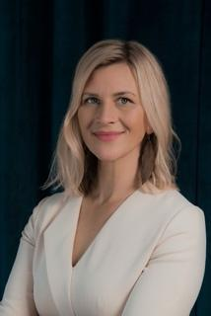
Dr. Angela Loucks Alexander, Audiologist, specializes in diagnosing and treating Auditory Processing Disorder (APD). Angela's TEDx Talk "Escaping the Hidden Prison of Auditory Processing Disorder" was the most-watched TEDx worldwide in September 2021 and has more than 1 million views. She hosts the Between Two Ears podcast and directs the Auditory Processing Institute, where she trains audiologists and speech-language pathologists to provide APD services. She has also created an online, searchable map to help clients find the help they need at www.APDsupport.com/apdmap

About Dr. Robert DiSogra

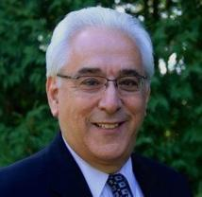
Dr. Robert DiSogra, AuD, is a widely recognized pioneer in the field of audiology. He has dedicated the majority of his career to promoting an understanding of the pharmacologic effects on hearing and balance among audiologists around the world. While teaching at Rutgers University over 25 years ago he questioned why his patients had clinical complaints of hearing loss, yet their test data showed no evidence of peripheral loss. He then went beyond his clinical practice to initiate an unprecedented review of evidence that identified the influences of pharmaceuticals and nutraceuticals on hearing loss and tinnitus. In a series of publications for audiologists over the past 20 plus years, Dr. DiSogra distinguished his audiology career by identifying over 400 adverse auditory/vestibular side effects related to more than 2000 drugs. By 2019, 25 AuD programs were offering a dedicated pharmacology course, in part, because of this pharmacological connection to hearing and balance disorders. Dr. DiSogra has left a legacy for our field. He recently served on the Academy’s Pharmacology Task Force, which explored the requirements for prescriptive privileges for audiologists.

# # #

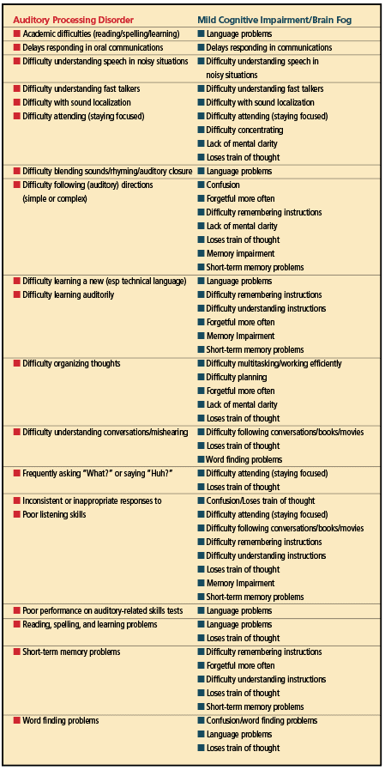

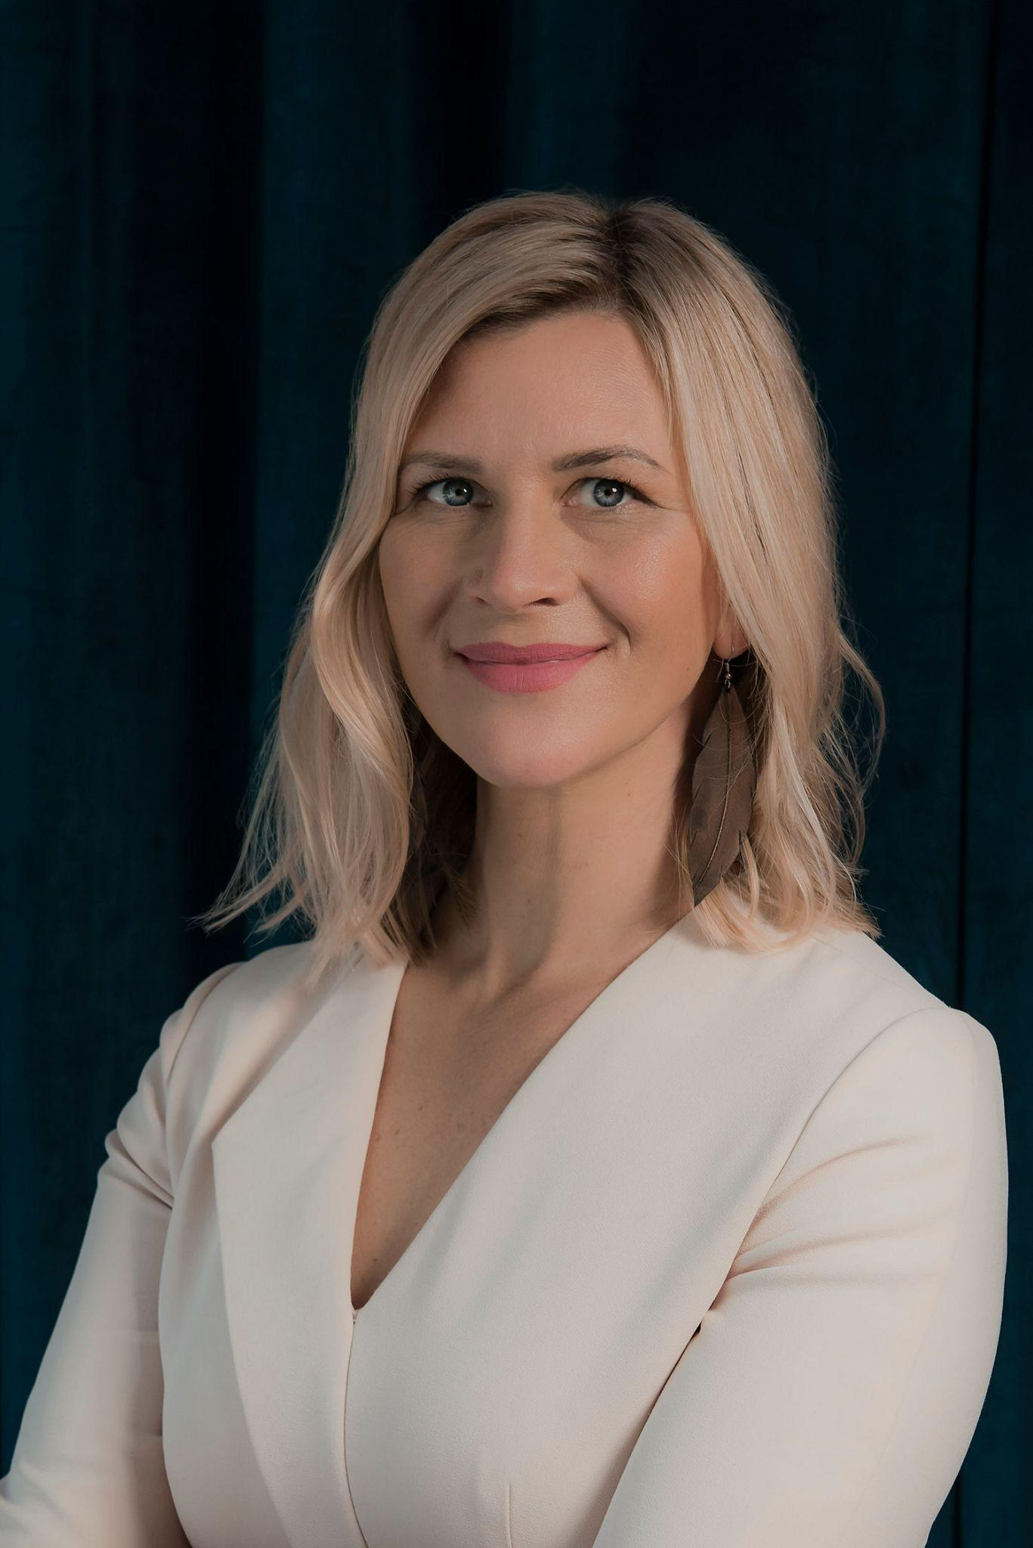
Angela Alexander, AuD, CCC-A
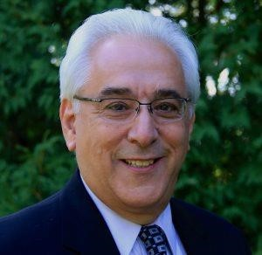
Robert DiSogra, AuD

