Rhino Tool House Media Contact
Steven Vogt
Phone: 262.710.4191
Fax: 262.796.1194
Email: steven.vogt@rhinotoolhouse.com

Press Release

Rhino Tool House Welcome Industrial Equipment Corp. (IEC) to the Distribution Family

CONCORD, NC October 21, 2020: Rhino Tool House proudly announce the acquisition of Industrial Equipment Corp. (IEC) located in Shoemakersville, PA.

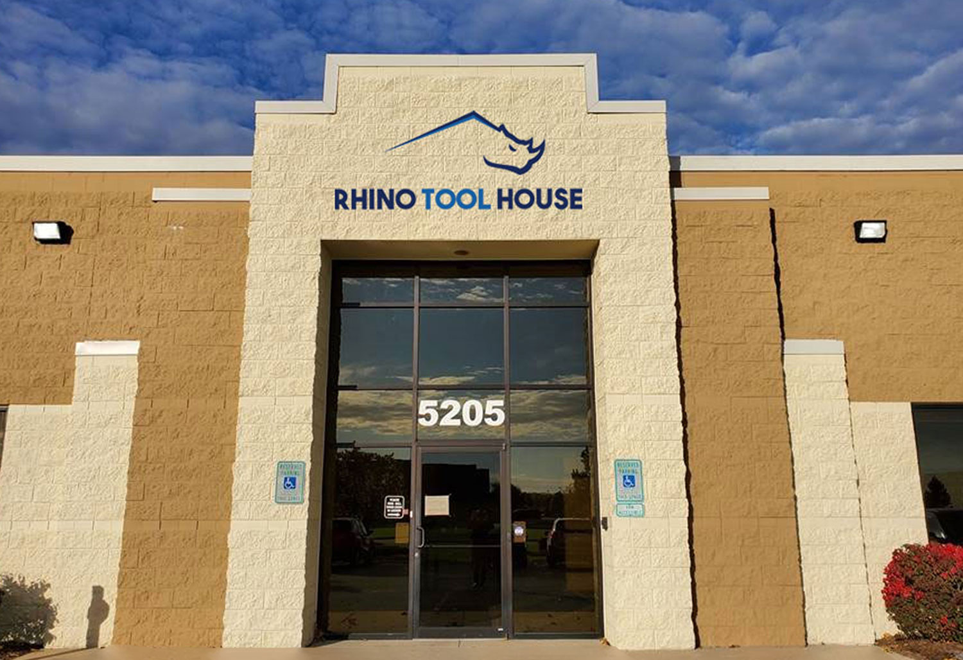
At Rhino Tool House, our core focuses are identifying and delivering the world’s most innovative industrial solutions, providing superior service with local expertise, all to empower our customers to be more productive, build a better-quality product, and maintain a safe environment for their workers. These business values mirror those of IEC and are only part of what makes IEC such a valuable member of this great organization.
“We are excited to welcome the IEC team into the RTH family. This will strengthen our presence in the region and allow us to offer more products and services as a result.” – Dan Brooks, CEO
The IEC team has been serving customers throughout the eastern United States since 1988. Along with a familiar name in the industry, IEC brings with them a great team of value-added application specialists, and a vast resource of technical support from the sales and support staff at IEC.
With the addition of IEC, the unified Rhino Tool House Company continues to expand to better support our manufacturing customers looking to revolutionize their processes. Our customers can now reap the benefits of this expanded network of application specialists focusing on industrial tooling, automation, material handling, and abrasives.

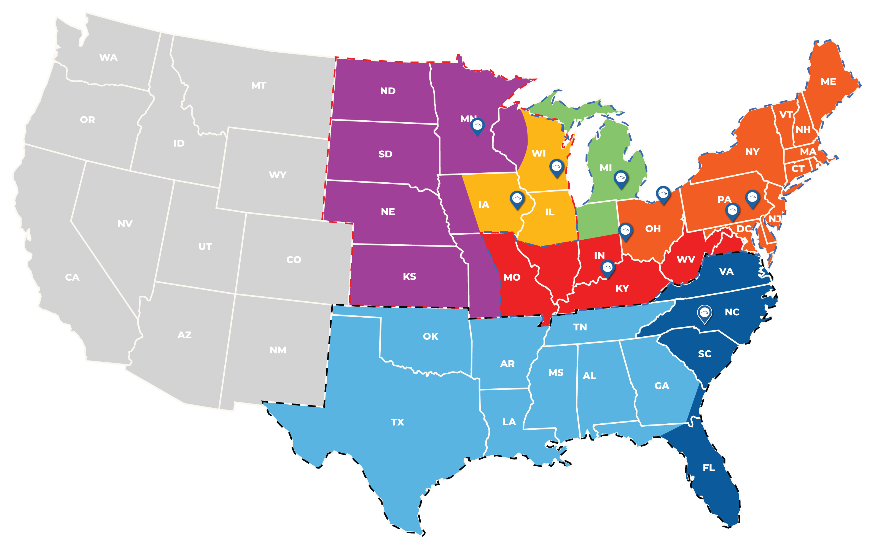

Regional Sales Map

About Rhino Tool House:
Rhino Tool House is an organization born of like-minded businesses dedicated to providing the highest level of detail, service, and support for the industrial market. We continue to expand our footprint, our product and service offerings, and our expertise through strategic acquisitions, hiring and developing the most experienced personnel in this space, and a persistent ambition to be the best partner for our customers anywhere in the industrial market.
Our key areas of focus include assembly tools, industry 4.0, material handling, automation and robotics, error proofing, wearable technology, custom solutions, pumps and hydraulics, as well as service and calibration services for everything we offer.
Vision Statement
In a highly dynamic world, we exist to revolutionize your process. Through our culture, we will create strategic partnerships with our employees, customers, and stakeholders.
Mission Statement
Our mission is to identify and deliver the world’s most innovative assembly solutions. We provide superior service, local expertise, and a high degree of responsiveness to empower our customers to be more productive, build a better-quality product, and maintain a safe environment for their workers.
Certifications:
ISO 9001:2015
ISO 14001:2015
ISO 17025: 2005, 2017 Accredited Service Centers

Rhino Tool House Family of Companies:
www.rhinotoolhouse.com
www.rhinoassembly.com
www.toolhse.com
www.katechnologies.us
www.excelairtool.com
www.buckeyetools.com
www.hovairauto.com
www.gdhoist.com
www.fxdtorquetools.com
www.ramservicegroup.com
www.ctrtoolservice.com

