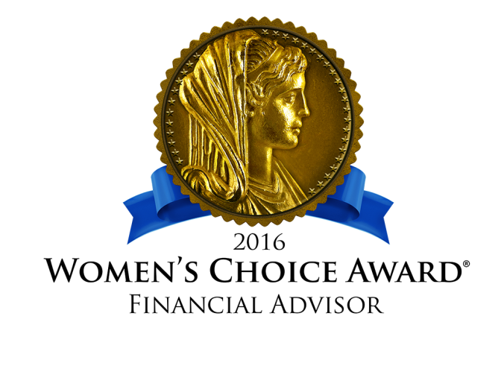
Media Inquiries:
Mosaic Financial Partners
Channing Hussey
info@mosaicfp.com|415-788-1952

Women’s Choice Award®
Madelyn Martinez
mmartinez@womenschoiceaward.com|954-922-0846

FOR IMMEDIATE RELEASE
Mary Ballin of Mosaic Financial Partners receives the Women’s Choice Award®, is recognized as a highly recommended financial advisor by women for women
San Francisco, CA: March 21, 2016 - As the leading advocate for female consumers, WomenCertified Inc. is pleased to announce that Mary Ballin has received the Women’s Choice Award for Financial Advisors and Firms.
Based on rigorous research, 17 objective criteria and additional points of reference that obtain feedback regarding the advisor’s service and practices, the Women’s Choice Award is the only recognition program for well-qualified advisors who are committed to the women’s market and serving their female clients. Achieving this award reaffirms the commitment Mary Ballin has to extraordinary service in addressing the financial needs of women and their families. “I have a passion for providing education to women about a wide variety of personal financial topics,” Mary notes. In addition to her exemplary work with clients, Mary is active in her community and in furthering her profession. Recently, she spoke to the Girl Scouts of San Ramon about working as a financial planner. In addition, Mary co-founded Mosaic Women’s Circles, a quarterly finance-focused discussion group for women to explore their relationships with money and to learn from each other’s experiences.
WomenCertified, originator of the Women’s Choice Award, was created by Delia Passi, the leading advocate for female consumers and former group publisher of Working Woman and Working Mother magazines. Delia has created the Women’s Choice Award for Financial Advisors in an effort to help women identify those advisors who are committed to
Mary Ballin of Mosaic Financial Partners receives the Women’s Choice Award®- page 2 of 3
providing quality service. The award allows this outstanding group of advisors to showcase their commitment to the women’s market, while giving potential clients a starting point for entrusting their finances to an advisor.
Recent studies indicate the following in regards to women and their finances:
- Only 35% of women use a professional financial advisor, most (79%) doing so for retirement investment recommendations. *
- In the US, Women control about $11.2 trillion of the nation’s investable assets (39% of the country’s estimated $28.6 trillion of investable assets). Nearly half of that amount is managed solely by women. **
- Fewer than two in 10 women feel “very prepared” to make wise financial decisions. Half indicate that they “need some help,” and one-third polled feel that they “need a lot of help.” ***
As the financial industry wakes up to the fact that a great majority of the female population are seeking advisors they can trust and greatly value financial security, WomenCertified Inc. has created the solution. This powerful, national initiative distinguishes advisors who support female consumers in their quest for financial education.
###
ABOUT THE FIRM AND THE ADVISOR
Mosaic Financial Partners is a San Francisco-based independent, fee-only wealth management boutique providing both financial planning and investment management services to individuals and families since 1987. The foundation of our work is our individualized financial planning process, which allows us to get to know each client’s unique personal and financial needs and offer fully customized advice. This understanding allows us to create an investment management strategy that integrates your finances with the rest of your life, creating a rich mosaic of what is truly meaningful for you.
Mary Ballin joined Mosaic in 2003. Her specialty is working with women who have experienced a life transition, such as divorce, widowhood, marriage, or an unexpected loss.
Mary Ballin of Mosaic Financial Partners receives the Women’s Choice Award®- page 3 of 3
ABOUT THE WOMEN’S CHOICE AWARD
The Women’s Choice Award Financial Advisor Program is based on 17 objective criteria associated with providing quality service to women clients such as credentials, experience and a favorable regulatory history, among other factors. Financial advisors do not pay a fee to be considered or placed on the final list of Women’s Choice Award® Financial Advisors, though they may have paid a fee to participate in the Women’s Choice Award Financial Advisor Marketing Program. WomenCertified Inc., home to the Women’s Choice Award, awards businesses, brands and services based on high recommendation ratings by female consumers. The Women’s Choice Award represents the collective voice of women so they can help each other identify businesses that deserve their loyalty and referrals. To learn more, visit www.womenschoiceaward.com.

* 14th Annual Transamerica Retirement Survey of Workers (2014)

** Source: Harnessing the Power of the Purse, by the Center for Talent Innovation 2014

*** Source: Financial Experience and Behaviors Among Women, 2010−2011 Prudential Research Study (article breaking it down here).

