Western Digital Announced as CSCMP San Francisco Roundtable “High-Tech” Event Sponsor

Featured Speakers to Represent Cisco, GoPro, Sonic Manufacturing, Walmart E-commerce, and Western Digital

SAN FRANCISCO, CA, February 13, 2018 – Western Digital has been announced as the sponsor for the upcoming CSCMP San Francisco Roundtable supply chain networking and dinner event titled “Winning Supply Chain Strategies in High-Tech Industries.” The dinner event takes place on February 22 at the GoPro ‘Barn,’ at corporate headquarters in San Mateo, CA, runs from 5:30 to 8:30 p.m. and features senior supply chain executives representing Cisco, GoPro, Sonic Manufacturing, Walmart E-commerce, and Western Digital.
CSCMP SFRT president, Michele Carroll stated, “We are grateful to Western Digital for their sponsorship of our High Tech Supply Chain event, which promises to be an impressive panel of distinguished Silicon Valley leaders showcasing transformation of challenges to competitive advantage.”
Event Chair Moin Islam of Western Digital invites the panel, to be moderated by Dr. Naren Agrawal of the Leavey School of Business, Santa Clara University, to address winning supply chain strategies that high-tech companies are adopting to optimize their supply chains in the competing directions of cost, speed and agility.
Panel Moderator
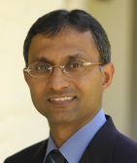
Dr. Naren Agrawal
Benjamin and Mae Swig Professor,
Dept. of Operations Management & IS
The Leavey School of Business, Santa Clara University

Speakers
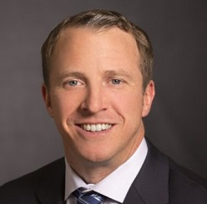
Colin Chummers
Sr. Director, Network and Partner Services
Cisco Systems

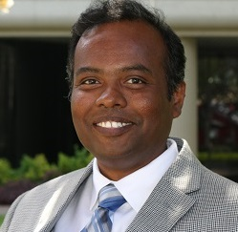
Shiva Esturi
Fellow, Supply Chain Strategy and Optimization
Western Digital Corporation
Speakers (continued)
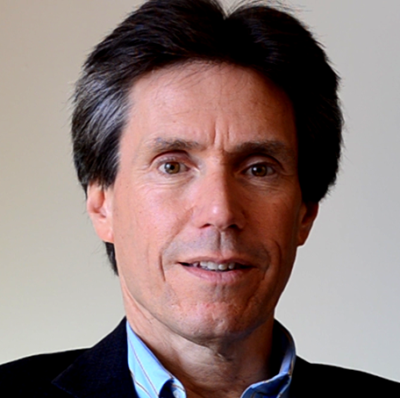
David Ginsberg
Vice President, Supply Chain Management
Sonic Manufacturing Technologies

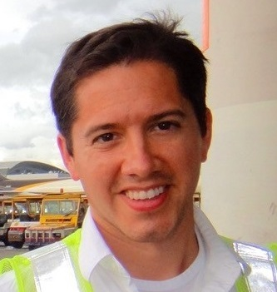
Jeremiah Pomerleau
Senior Manager, Transportation and Trade Compliance,
GoPro, Inc.

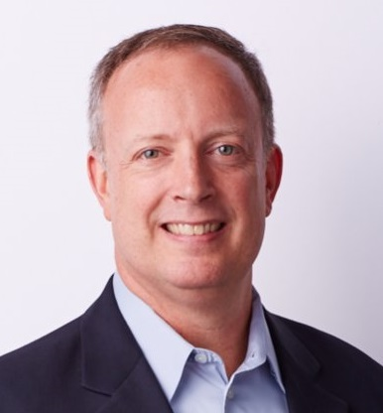
Ray Ernenwein
Director, e-Commerce Supply Chain Strategy & Analytics
Walmart Inc.

For additional information and to register go to: http://cscmpsfrt.org/event/winning-supply-chain-strategies-in-high-tech-industries/

About CSCMP
Serving 9,000+ members worldwide, the Council of Supply Chain Management Professionals (www.cscmp.org) is a non-profit membership association that helps supply chain managers and executives connect, collaborate and become more effective professionals. One of the most dynamic of its 100+ Roundtables around the globe, the San Francisco CSCMP provides regular educational events, networking opportunities and a scholarship program. For more information, please visit www.cscmpsfrt.org.

