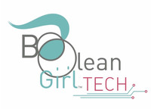
Boolean Girl Tech
815 N Barton St, Arlington, VA 22201
info@booleangirl.org booleangirltech.com
News Release

FOR IMMEDIATE RELEASE FOR MORE INFORMATION
January 29, 2021 Chelsea Stern
PR and Outreach Assistant
(856) 577-0302
chelsea.stern@booleangirl.org

Boolean Girl Tech Launches New Boolean Box STEM Enrichment and LEGO Building Kit

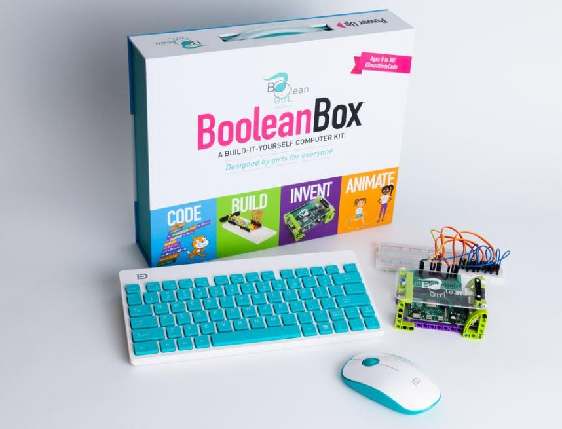
WASHINGTON—Boolean Girl announced the launch of its newest version of the Boolean Box, an interactive tool kit for kids to build their own computer and learn to code, build, invent and animate, to be released in February 2021. The new Boolean Box features a case built from LEGO® compatible bricks for familiar fun and easy assembly.
“Kids love Lego® bricks and love building their own case so this is a fun way to extend the STEM learning experience even more,” said Brian Moran, co-founder of Boolean Girl.
The Boolean Box can be endlessly customized by using any bricks. It's easy to snap into a brick project and use the box to control motors, lights, motion sensors, light sensors and other electronics that bring brick projects to life with STEM.
The box is designed to work with all Lego® compatible bricks but specifically with LEGO Technic Blocks and Lego power function projects. Complete with a computer, the Boolean Box can be used to build a motor controller, write your own code and drive your brick projects from the computer.

(more)

“This is a super fun toy that kids will never get bored of, and parents will love the fact that it promotes imaginative discovery and an awareness of how physical objects relate and interact with one another,” said Sarah Eastman, co-founder of Boolean Girl. “The best part is kids won’t even realize they’re learning so much.”
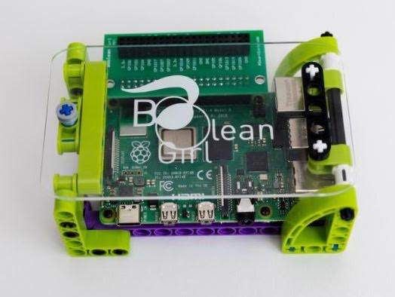
In addition to providing a hands-on learning experience, the Boolean Box promotes , self-expression, problem-solving and critical thinking. With a toy-like model, the new Boolean Box presents children with endless possibilities to express their creativity through code, build and invent fun programs and animate characters. As users build projects, they are learning to code and work with electronics, real-world skills that translate to high demand careers, in a fun, game-like format.

As a supplementary component to the Boolean Box, the kit is supported by online learning workshops. During a time of remote educational frameworks, Boolean Girl has opened up an ecosystem of STEM camps and classes with the “Full STEM Ahead Virtual Learning” program.

The new Boolean Box will be available on the Boolean Girl Tech website (booleangirltech.com), Walmart.com, and Amazon (amazon.com).

About Boolean Girl and Boolean Girl Tech

Over the past several years the non-profit Boolean Girl has taught hundreds of girls to code and build things with electronics. In 2013, the team started looking for a kit that students could bring to class, set up quickly and use to teach girls to code and engineer. The answer was a Raspberry Pi and everything needed to make it usable including a keyboard and mouse. The result was the Boolean Box. Since then, thousands of boxes have been sold to help launch the STEM revolution.

# # #

