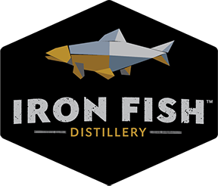
THE RETURN OF A LEGENDARY FISH THROUGH BOURBON
Final Release! 100 Bottles of Barrel Strength Estate Farm and Distilled Bourbon - Ushering the ‘Comeback of Michigan’s Lost Treasure’ the Arctic Grayling Fish
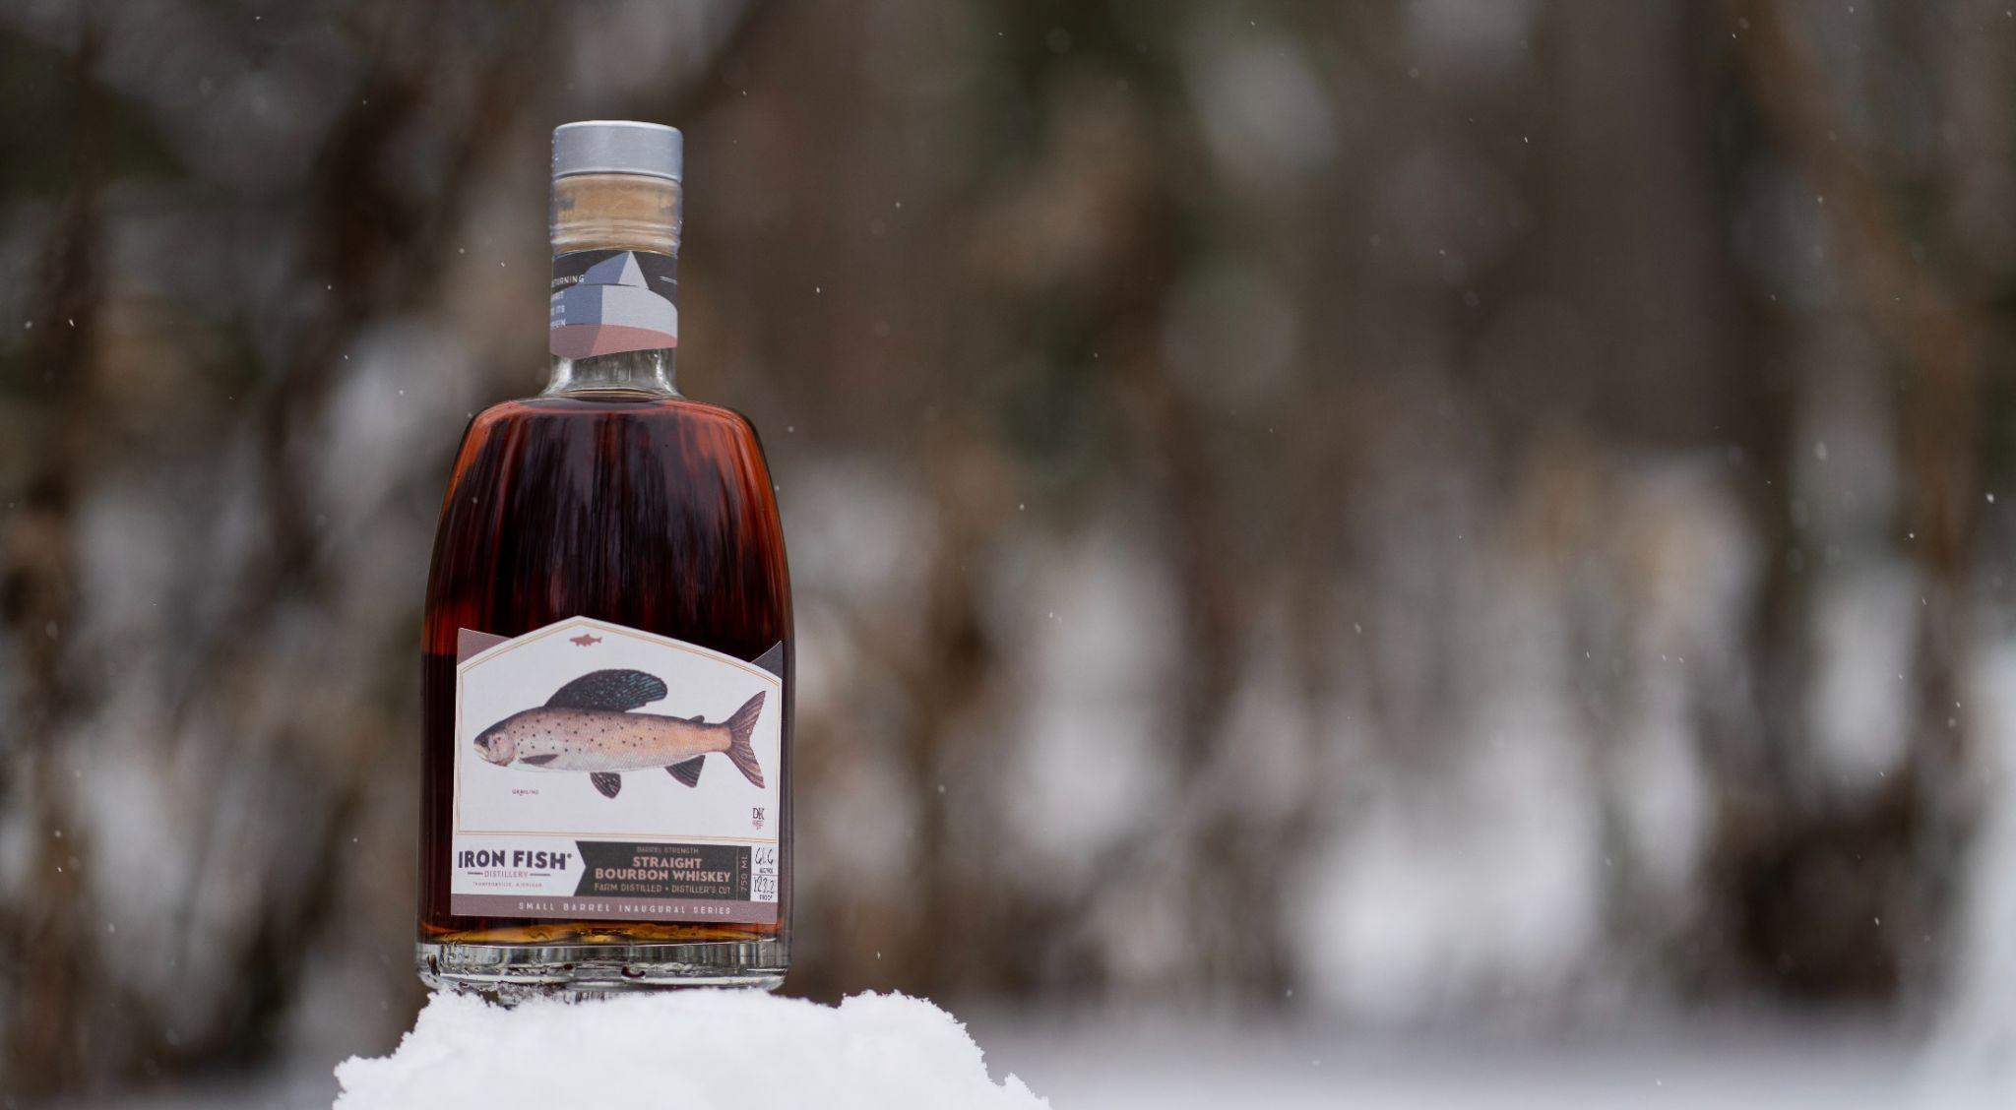

For Immediate Release Contacts:
Richard Anderson, Partner (906) 362-5100
Richard@ironfishdistillery.com

(Thompsonville, MI) March 16th, 2022 –The Arctic Grayling Whiskey Series celebrates the Michigan Arctic Grayling Initiative, over 40 organizations working since 2016 to restore self-sustaining populations of Arctic Grayling in Michigan rivers. In 2017, we set aside a few barrels of farm grown, estate grain and distilled whiskey for initial release in 2019 featuring a label design donated by Michigan artist, Dani Knoph. Iron Fish Distillery also established and joined supporters in contributing to the Iron Fish Arctic Grayling Research Fund. The fund supports related research underway at Michigan State University.

This 4 year old Straight Bourbon Whiskey made from 100% Michigan grain, will feature a beautifully hand drawn Grayling print by Michigan artist Dani Knoph. "The story of Michigan's lost Grayling is now a comeback story—full of hope, challenge, science, and partnership." said Knoph.
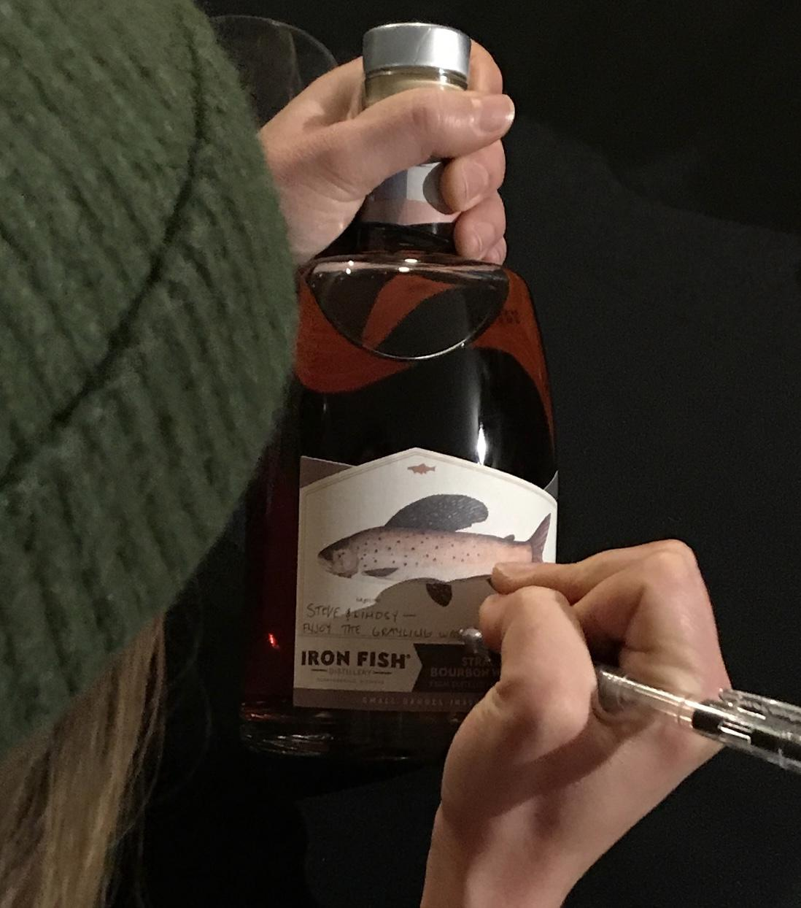
"Restoring Michigan's wild Grayling encourages us to learn from the past, evaluate the present and define the future. From Montana and Alaska to Michigan, many people are caring for this native species. It gives me hope. it's the Native American Seven Generations principle at work."

Iron Fish joins the initiative to draw attention to the groundbreaking research at Michigan State University, supported by over 40 groups statewide including the Michigan Department of Natural Resources Fisheries Division, the Little River Band of Ottawa Indians, the Wenger Foundation and Trout Unlimited Chapters.

APRIL 2ND ARCTIC GRAYLING RESEARCH DISCUSSION
Join us for a presentation by Nicole Watson PhD, on the Arctic Grayling Initiative at 1pm or 3pm on Saturday, April 2nd at Iron Fish Distillery (space limited).

Nicole Watson is a PhD Candidate with Michigan State University, Department of Fisheries and Wildlife. Her research focuses on addressing key questions to a successful reintroduction of Arctic Grayling to Michigan streams. She will be discussing her research findings with a focus on young Arctic Grayling and competition and predation with young Brook and Brown trout. Nicole will also provide a summary of the current status of the reintroduction and its future and be available for open Q&A.

This event is FREE of charge. Please RSVP through Eventbrite. For more info please contact Info@Ironfishdistillery.com

ABOUT THE BOURBON
Claim your Iron Fish barrel strength estate bourbon, aged over four years, featuring a mash bill of:
- 70% organic corn
- 16% Iron Fish estate grown wheat
- 9% barley
- 5% Iron Fish estate grown rye
100 bottles available until they sell out. Here's how to buy:

DONATE TO BRING BACK THE GRAYLING The public can join Iron Fish Distillery in supporting research for the Michigan Grayling Initiative by donating at the link HERE: https://manisteefoundation.org/donations/

CLAIM YOUR BOTTLE: The general public may purchase bottles starting at 1PM. All bottles are sold on a first come basis, and the public sale will follow Iron Fish Steelhead and Flycaster member purchases. Only 100 bottles will be released and there is no guarantee of purchase.

Limit of 2 bottles per household.
($100 per bottle + tax)

About Iron Fish Distillery
Iron Fish Distillery is Michigan’s first farm distillery, growing grain and distilling spirits, and barrel finishing sourced whiskey. This MAEAP certified working farm and distillery attracts over 100,000 guests annually to the agricultural destination, reborn on a long-time abandoned 120-acre farm located in rural Springdale Township in Manistee County.

Every step of our soil-to-spirit process occurs onsite. The process starts in our farm fields where we grow and harvest our own grain. We then mill, mash, ferment, distill, and barrel age our spirits on the property. Iron Fish also sources bourbon for finishing in barrels from around the world. To date, our library of barrel aged spirits exceeds 1,000 barrels, consisting of carefully sourced farm barrel finished whiskies and estate whiskies distilled from grain grown on our farm and from nearby farms.

About The Return of the Native: Arctic Grayling
This remarkable project to restore grayling in select Michigan rivers is made possible by the Michigan DNR, the Little River Band of Ottawa Indians, and the Wenger Foundation with support from over 50 partners, including Trout Unlimited Chapters across the state of Michigan. Learn more at migrayling.org.

About the Iron Fish Arctic Grayling Research Fund
Be a part of something important. Join us in our support of foundational research into the reintroduction of Michigan Arctic Grayling to its home waters by going online to manisteefoundation.org/migrayling and contributing to the Iron Fish Arctic Grayling Research Fund, a component fund of the Manistee County Community Foundation.

# # #

