NY Knicks legend Dick Barnett and A-List Education to launch Dr. Richard Barnett Scholars Program, a multi-year college and career readiness Pathway Program for NYC 9th Graders in January 2022

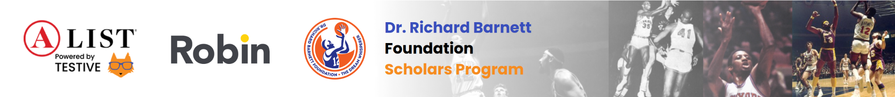

Partnered with A-List Education and social-emotional learning provider Robin, the Dr. Richard Barnett Scholars Program is seeking up to 25 students in the 9th grade who are determined to reach their dreams.

New York, NY, November 9th, 2021: –
The Dr. Richard Barnett Foundation Scholars Program levels the playing field for students in the New York City area by connecting them with college and career success resources and giving them the tools to unlock their confidence, ambition, and purpose. Through the lens of athletics, the program engages students to create their own success by exposing opportunities in sports and adjacent careers, vocational programs, and 4-year colleges. By developing the whole person, the Dr. Richard Barnett Foundation Scholars Program sets its scholars up for success in life — not just high school and college.

We believe success starts with education, mental wellness, and big dreams. From college prep classes to unique workshops led by legends on and off the field, these experiences break down the traditional classroom and marry technology to experiential learning.

Students will be supported from 9th grade through their first year in college with:
- Engagement with the NBA and others
- One-on-one college and career guidance
- Small-group academic tutoring
- Career days
- Internships
- Scholarship opportunities
- Mental wellness resources and small group coaching

This FREE program starts in January 2022, and we are accepting nominations through December 13, 2021 at 5pm — nominate yourself or a student today!

For more information on the Dr. Richard Barnett Foundation Scholars Program, visit our webpage at https://alisteducation.com/dr-richard-barnett-foundation-scholarship-program/

About the Dr. Richard Barnett Foundation
Founded by New York Knicks legend Dick Barnett, the Dr. Richard Barnett Foundation inspires and empowers youth to chase and achieve their dreams. A core part of that mission is to support more and better pathways to higher education, especially elevating opportunities and leveling the playing field for historically underrepresented students and HBCUs.

About A-List Education
A-List Education is proud to support the foundation's work with high school students as they prepare for college and career, and is committed to providing instruction, professional development, innovative learning support, and social-emotional resources to students, schools, teachers, and families across the country. Equal access to education should be a right, not a privilege, and we fight every day to make that a reality.

About Robin
Robin is the only social-emotional learning solution that connects students with coaches and curriculum to build skills to thrive when facing life’s toughest challenges. Partnering with schools, Robin customizes social-emotional learning programming to address students’ real life needs. Robin’s unique group coaching experiences can be combined with a flexible toolbox of on-demand Tier 1 curriculum. Students learn and practice skills to build self-awareness, self-esteem, resilience, connection, purpose and the critical thinking skills to make good choices.

