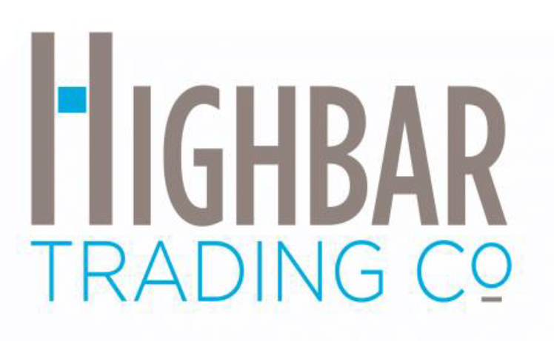
FOR IMMEDIATE RELEASE

Contact: Todd Miller
todd@highbartrading.com
901-762-1270

Thinking Civically – Memphis, TN Based Business with National Capabilities - Highbar Trading Co. – Memphis, TN

Keeping business local has its upside

MEMPHIS, Tenn., January 6, 2023 – It has been 5 years since Justin Miller, Todd Miller, Ben Miller, and Mark Light started a quest to serve clients, whom they look at as business partners, by providing fast, efficient, and cost-saving operational commodities. The Millers left Yuletide Office Solutions in 2017 to make that dream a reality. Recently, Yuletide has sold to a firm based in Nashville. Highbar Trading Co. is one of a few suppliers left that are based in Memphis, TN.

The Highbar team practices and preaches civic economics. Since their inception, they have partnered with local: car dealerships, banking institutions, insurance companies, financial institutions, and many other entities. “Creating a reciprocal partnership always gives the business on both sides longevity”, said Todd Miller, co-founder of Highbar Trading Co. Studies show that for every $100 spent locally, $68 stays in the community. While, $100 spent with non-local businesses, only $43 stays in the community. This can have a tremendous impact on a macro level.

Local companies can compete with larger competitors. “There is a misconception in many communities that local companies cannot compete with larger conglomerates. The truth is, we have much lower overhead than these organizations, which makes our cost to serve less than our competition”, said Justin Miller, co-founder of Highbar Trading Co. A recent study shows, that 70% of Americans prefer to shop local. “This is encouraging for Memphians considering starting their own businesses. Since the pandemic, we are seeing many new restaurants and retailers opening around the city of Memphis”, said Justin Miller.

Highbar is currently delivering into the Tri-State area (Tennessee, Mississippi, and West Memphis, Arkansas) with their own delivery vehicles, but also drop shipping into 47 states. They purchase truckloads of janitorial paper products, bottled water, copy paper, disposable gloves, surgical masks, bouffants, as well as other commodities to mitigate the hyperinflation and supply chain issues in the market.

Keeping business local has its upside. “Since the pandemic started in 2020, we have seen market dynamics never experienced before. Inflation is at an all time high and supply chain disruptions have caused issues with many operational commodities companies use to run their organizations. One way to solve this is by stocking these items in our two warehouses in Memphis, TN. This gives us full control of distribution, the autonomy to offer just-in-time inventory for our clients, and the ability to ensure that we never run out of product. “We are also available for our clients 24/7. Accessibility is key when needs become urgent. This allows us to be an extension of our clients’ business”, said Todd Miller

Purchasing direct from manufacturers, Highbar Trading Co. capitalizes on the aggressive pricing and the variety of over 100,000 items they offer. Highbar Trading Co. offers many product categories including: office supplies, ink/toner, break room supplies, bottled water, disposable gloves, coffee, packaging supplies, safety supplies, lab supplies, transactional office furniture, contractual office furniture, medical supplies, covid tests, printing, and PPE. Essentially, they run the gamut for operational needs for any organization. More information can be found at www.highbartrading.com.

PHOTOS:
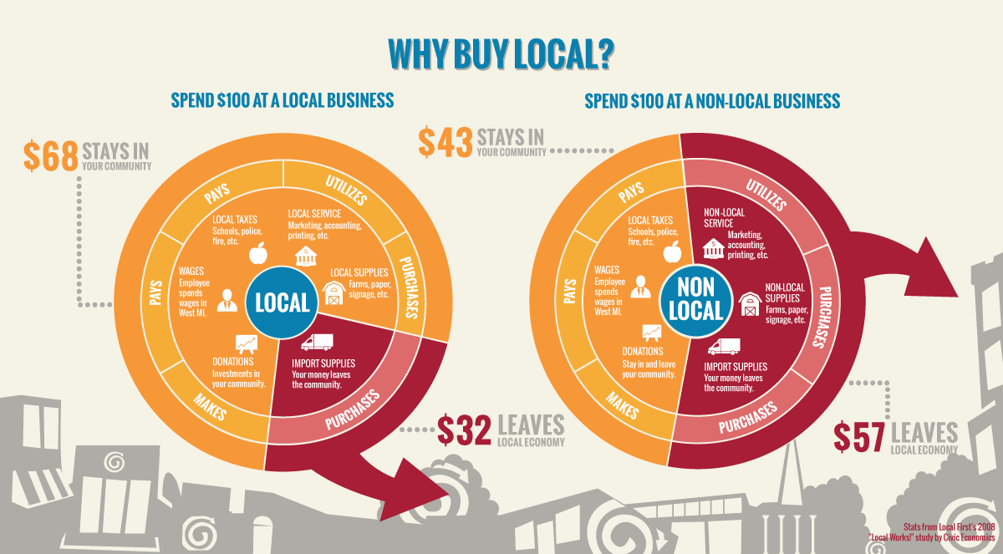

Civic Economic Chart.

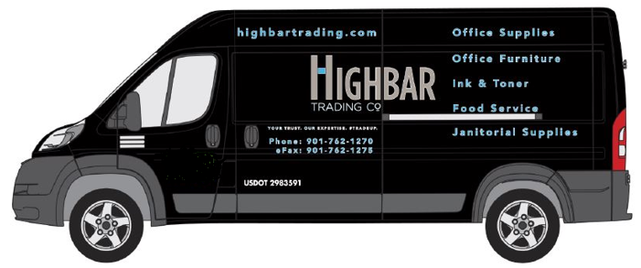
Highbar Trading Co. delivery vehicle.

About Highbar Trading Co.:

Highbar Trading Co. is an organization which distributes operational commodities with a low cost to serve using a technology driven approach to the marketplace. They use a combination of stocking and virtual inventory platform to fulfill the needs of customers with next day national delivery and emergency same day delivery in some markets. By using a digital approach to the marketplace, it has allowed their company to quickly expand. Highbar Trading Co. uses 44 virtual inventory fulfillment centers across the country with access to 1000+ manufacturers from a single source. The company was founded by Justin Miller, Todd Miller, Ben Miller, and Mark Light. The team has a combined 50+ years of experience in Sales, Marketing, Logistics, Information Technology, and Finance.

