Voice Privacy is Paramount on Capitol Hill
Using a Stenomask keeps private conversations, transcriptions and recordings private!

A verbatim court reporter transcribes testimony from James Comey during the Senate Intelligence committee hearing on Trump and the Russia probe. He is using a Stenomask microphone made by Talk Technologies. Stenomask was invented over 70 years ago by the founder of the company and its applications are more relevant today than ever before. Talk Tech recently announced the release of their 6th generation Stenomask, the Steno SR series.
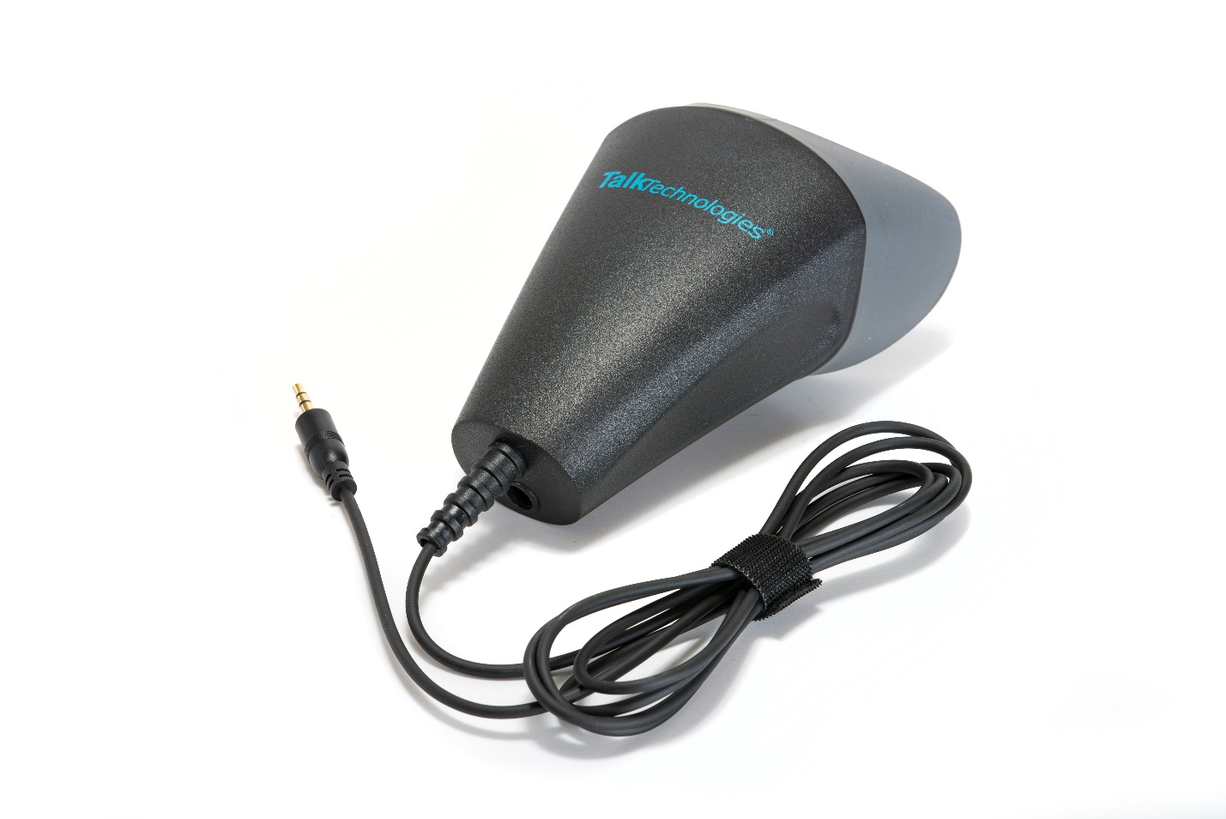
https://talktech.com/stenomask-steno-sr/
The Steno SR series microphone guarantees absolute voice privacy and a crystal-clear sound signal while simultaneously eliminating all background noise. Engineered to replicate the noise proofing properties of the world’s premiere sound booths the Steno SR yields 100% noise cancellation and the patented technology makes it the most accurate microphone on the market today allowing healthcare, security, legal and business professionals to communicate and transcribe in complete privacy.

Ideal for crowded and noisy environments where privacy and discretion is a must. Stenomask can be used with any type of device including, phones, tablets, computers, recorders, transmitters, two way radios and amplifiers. Wherever there is a microphone input, you can use a Stenomask.
talktech.com to learn more
About Talk Technologies: Talk Technologies Inc. founded in 1947 designs, manufactures and sells Stenomasks to business, industry and institutions around the world. Some of our valued clients include: U.S. Army Inspector General- Pentagon, U.S. Naval Justice Institute, National Guard Counterdrug Task Force, Massachusetts Institute of Technology: MIT, Kennedy Center for the Performing Arts and the NYC Department of Education.

