Kelly Haws
K42haws@gmail.com
Travel Essay Scholarship Contest
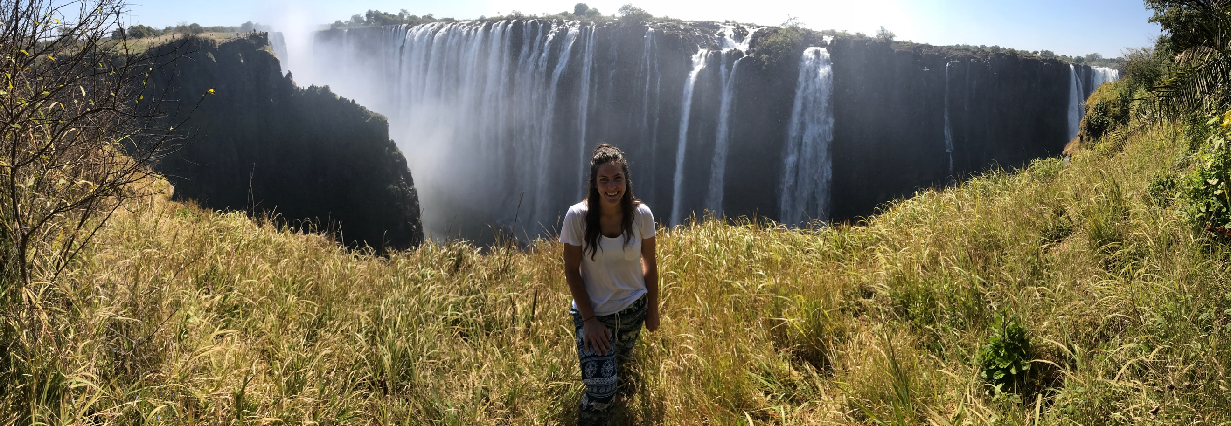
The brilliant Northern Lights of Alaska, the expansive Great Wall of China, or the rising Pyramids of Giza; each can take your breath away. All of these amazing places on our planet are at the grasps of the privileged traveler. The places that one sees when they travel are forever etched on their hearts and minds. However, it is in the people that occupy these places that beauty truly lies. Always changing and always unique; each face is different than the other, as is each story. Recently traveling to Africa, I was able to see the amazing expanse of water as the Zambezi River crashed over Victoria Falls, but I also saw the strength of the people in Zambia.
I traveled to Lusaka, Zambia in July of 2017 with a humanitarian group Mothers Without Borders, and I was forever changed by the process. My experience was humbling as it was empowering and inspiring. Throughout my life I had always had the desire to travel, but the looming financial expenses and the stresses of traveling frightened me. At the beginning of 2017, I found myself at a point in my life feeling very lost and ungrateful. I was focused on myself and my personal problems. Growing up my mother had always taught me, “The moment you feel sorry for yourself is the time to do something for someone else.” Leaning on that teaching, I took the leap into the unknown. With the generosity of so many people, almost all of my savings, and months of preparation I started my journey to Africa. My trip was personal with many aspects of introspection and growth. I was able to gain a sense of independence, traveling to the humid streets of Dubai, to my home sweet home for the time in Lusaka, and eventually to Livingstone. We were first welcomed to Africa by our ride, unfamiliar to any I had ever had in America, an old refurbished military truck. In the open truck bed were wooden benches for seats, and entry required the use of a stepping ladder. As we drove away from the airport, the warm African wind fought with my hair and children we passed waved with friendly curiosity. The first sunset I saw in Africa was unforgettable. From the open back of the truck bed, I watched the sun fall as the vibrant reds, purples, and oranges were painted into my memory forever.
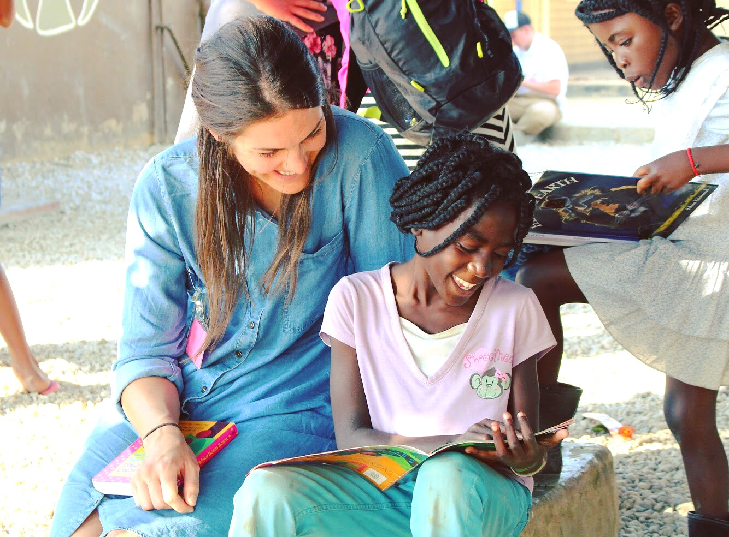
The dusty community of Lusaka is where I called home, and the people quickly became my family. During my time in Lusaka our group was able to travel to a new place every day. We saw the small faces of new born children abandoned by parents who had no other choice. We were able to hear the sweet laughter of orphaned children who had escaped the clutches of starvation and rape that is too familiar on their streets. Sadly, many of the children were already sick with AIDs and other illnesses. Meeting new faces every day accompanied with new stories, I was amazed of the hardship and struggle. However, one thing that was constant was the presence of joy with so little, and the persistence to endure because of their love for each other. I was able to learn so much about the power of hope and faith to overcome unfortunate circumstances and hardship. Mothers Without Borders currently has an orphanage that is a shelter to children that are brought to them. From hard work and the generosity of so many, they have been able to open a school for the children they shelter and those in the surrounding communities. It is evident in the Carol Zulu School that education is a generous gift for those lucky enough to receive it and it is treated as such. The children and the teachers of this school take pride in their building and cherish the education they are receiving. Many walk miles to school every day, these children and their families make huge sacrifices to better their lives and potentially break the pattern of poverty.
During my experience in Zambia, I was in awe of the beautiful landscapes and inspired by the people living in them. Completing my education and my personal goals will not only allow me to secure my future, but help those I come into contact with in ways that I have not previously been able to. My travel experience in Africa taught me so much, but I did not stop learning when I boarded my flight back to America. I recall on experiences and people I met there almost daily, and I am looking forward to when I am able to travel back. Today I am asking for your help financially to complete my education with the same hard work and dedication inspired by the children of the Carol Zulu School in Zambia.

