August 1st, 2022 – SAN JOSE, CA, POWER CENTER LLC, A DURACELL AUTHORIZED LICENSEE, LAUNCHES DURACELL HOME ECOSYSTEM

Power Center (www.duracellpowercenter.com) has expanded their product offering to launch Duracell Home Ecosystem, a suite of plug & play solutions including solar microinverters, expandable battery storage, level 2 EV charging and a mobile app monitoring platform. Duracell Home Ecosystem allows homeowners to produce, use, store and sell their own power while monitoring the entire home energy ecosystem through a convenient smart mobile app.

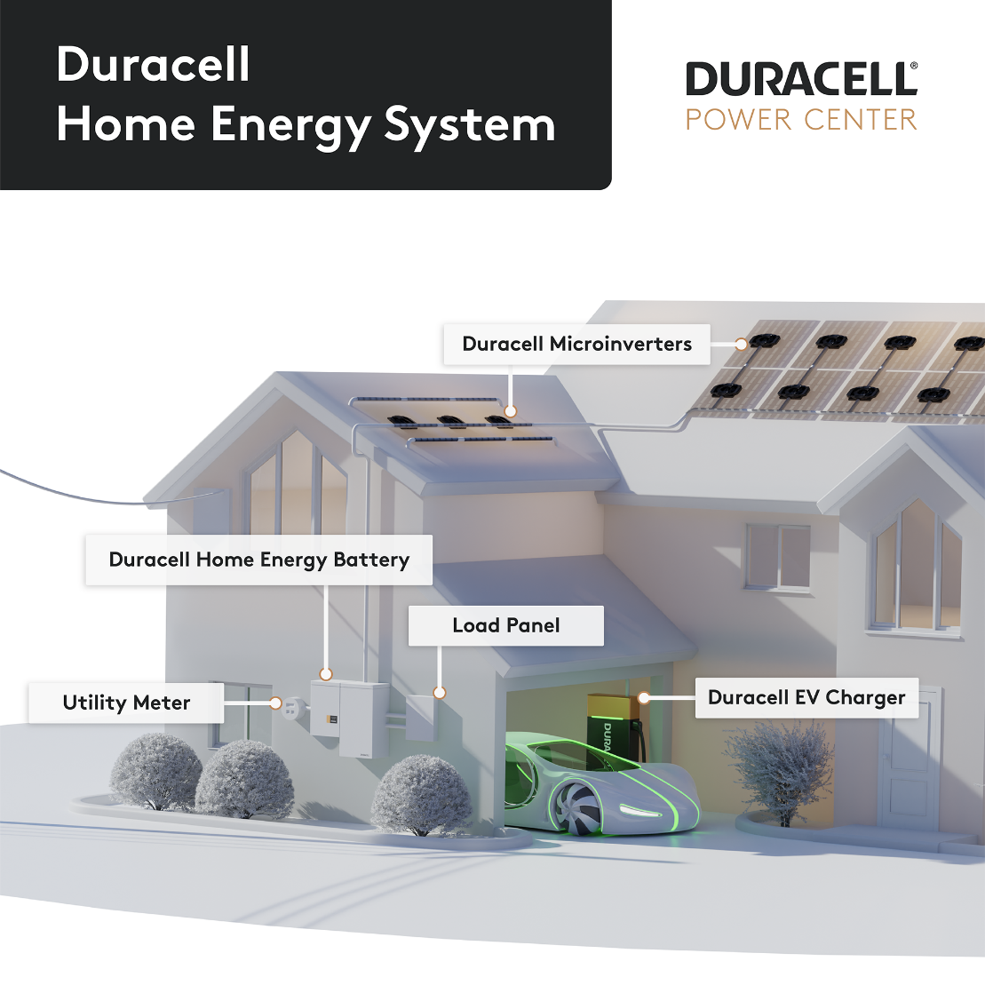

“Duracell is excited to see the market introduction of the full suite of innovative Power Center products which provide outstanding performance, value and convenience for homeowners” stated Mani Parmar, General Manager at Duracell.

Duracell Home Ecosystem offers a family of single, dual and quad microinverters that deliver the lowest cost, highest yield per solar module on the market. Installation is fast, easy and flexible, mating and covering wattage requirements of all solar modules on the

market today. Duracell Home Ecosystem microinverters provide individual level panel monitoring and optimization and the AC trunk cable format permits any combination of the three models to optimize even the most complex rooftop configurations.

Duracell Home Ecosystem also offers customizable LFP battery-based energy storage system solutions designed around their proprietary power electronics technology. AC-coupling and expandable storage capacity provide maximum installation flexibility. The 5 kW/14 kWh ESS option is currently available across North America and Power Center is currently taking orders for the 10 kW/21kWh ESS option which will be available for delivery beginning in September.

The Duracell Home Ecosystem 19.2 kW level 2 EV charger is the most powerful of its kind for residential applications, offering the capability to charge the broadest range of automobiles on the market as well as meeting the newest ISO 15118 standard for future vehicles. The EV Charger will be available in Q4 for delivery followed shortly with bi-directional charge capability to further enhance overall home energy management and control.

The Duracell Home Ecosystem also features both installer and consumer apps which can be found on Google Play and the Apple App Store, allowing for system monitoring, control and analytics.

“We have successfully mitigated supply chain concerns utilizing our key engineering and operations strengths. I am happy to report that product is available within all major
distribution channels in N. America and is supported by our tier one customer service organization”, stated Aakar Patel, President at Power Center, “we look forward to

enabling complete home energy management for each and every interested household under the incredible Duracell brand, all elements from the rooftop to the garage fully covered within one warranty”.

Interested parties may visit: www.duracellpowercenter.com or contact:

info@duracellpowercenter.com
1-833-DUR-APWR

About Duracell (www.duracell.com)

Started in the 1920s, the Duracell brand and company was acquired by Berkshire Hathaway Inc. in 2016 and has grown to be the leader in the primary battery market in North America. The iconic Duracell brand is known the world over. Our products serve as the heart of devices that keep people connected, protect their families, entertain them, and simplify their increasingly mobile lifestyles.

Our recharging technology allows consumers to live life without limits. Berkshire Hathaway Inc. is a $250B holding company owning subsidiaries that engage in diverse business activities. Visit www.duracell.com for more information; follow us on Twitter.com/Duracell and like us on Facebook.com/Duracell.

About Power Center (www.duracellpowercenter.com)

Power Center Home Energy Storage Systems leverage over 100 years of Battery and Power Management experience to manufacture innovative products locally in San Jose, CA. Power Center is an authorized licensee of Duracell. Duracell is a registered trademark of Duracell U.S. Operations, Inc.

