Invest in Our Planet, Invest in Our Future
-BLUETTI is actively responding to the call of Earth Day 2023.
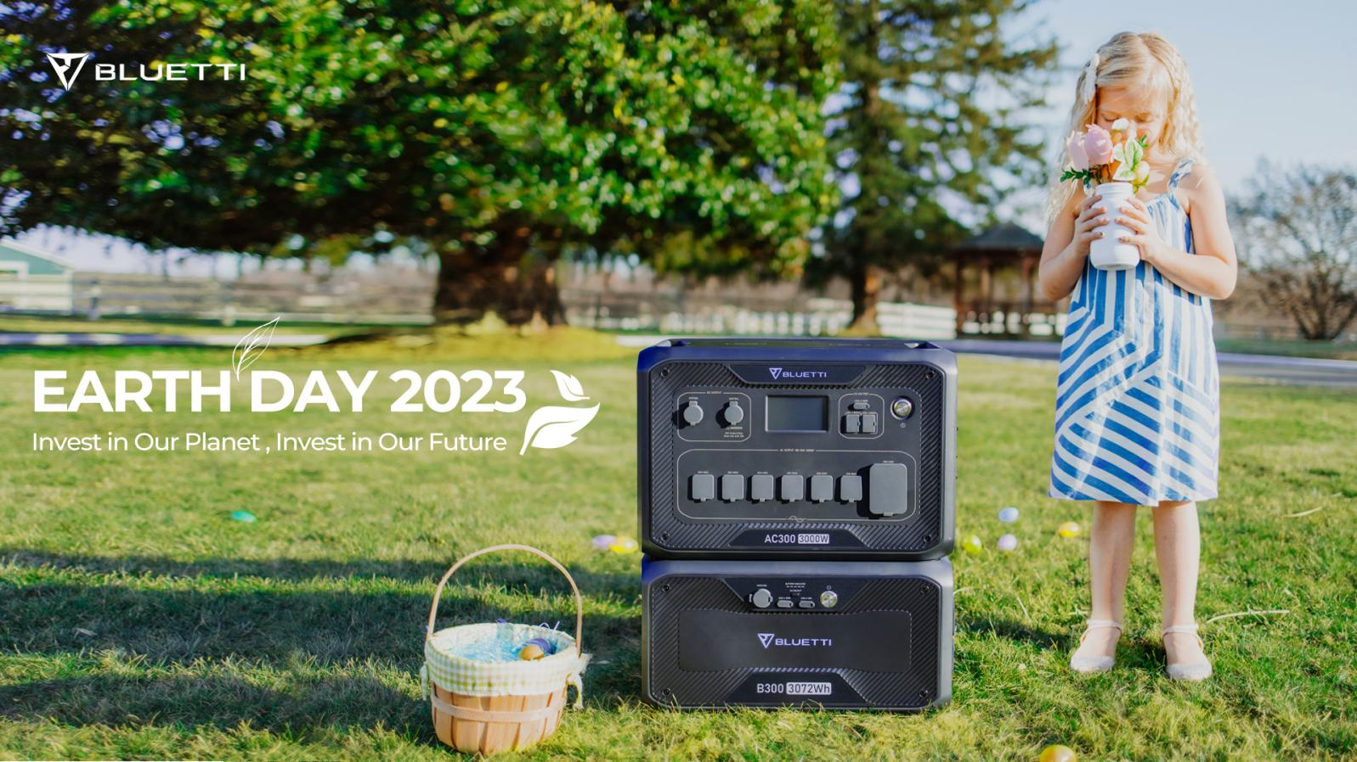
Our Earth is experiencing a tough period with terrible problems, for example, extreme weather problems. People have found out that living with a sustainable lifestyle is what everyone can do for the Planet. Therefore, we should attach more importance to the investment in our Earth.

BLUETTI, as a powerful leader with more clean energy solutions, has always advocated a green and sustainable lifestyle, for which is an achievable goal for every individual. BLUETTI is committed to developing an innovative renewable energy ecosystem, and becoming a contributor for this goal.

Green Power Solutions with Reliable Batteries
-Live it Safer & Reliable & Green
Most BLUETTI products are powered by lithium iron phosphate batteries with a durable 7-15 years service life, which are safer than traditional ternary batteries, and more environmentally friendly during its process of production, use and disposal.

The BLUETTI generator can be charged by both AC power and the green solar power. From EB3A portable mobile power supply to AC500 home backup battery , BLUETTI offers multiple sustainable energy solutions to meet the needs.

Get Ready for Sustainable Lifestyle
-BLUETTI is a key to a worry-free life.

Whether we enjoy outdoors shooting, camping or other activities, BLUETTI EB3A/EB55/EB70 will power our devices such as cameras, drones, phones, laptops or GPS. BLUETTI also provides AC200P/AC200MAX solar generators since they're able to carry refrigerators, microwave ovens and other electrical appliances, gather solar energy, and power for our easeful RV life.

Gain Supports From Bluetti's Buyers
-BLUETTI's concept of living sustainably is supported by our friends.

In the released BLUETTI documentary, our Australian friend Tom Phase lives in an off-grid farm, which is mainly powered by solar energy and generators. He bought AC300 and AC500 power supplies successively to build his farm.

BLUETTI will always strive to provide clean and independent, energy for all the human beings, let energy storage empower every family to live sustainably, and create a better world with love and innovation.

About BLUETTI
From the very beginning, BLUETTI has tried to stay true to a sustainable future through green energy storage solutions for both indoor and outdoor use while delivering an exceptional eco-friendly experience for our homes and our world. That's why BLUETTI makes its presence in 70+ countries and is trusted by millions of customers across the globe. For more information, please visit BLUETTI online at https://www.bluettipower.ca/ or follow BLUETTI on:

Facebook: https://www.facebook.com/bluetti.ca/
Instagram: https://www.instagram.com/bluetti_canada/
Twitter: https://twitter.com/bluetti_inc
Youtube: https://www.youtube.com/@BLUETTIOfficial

