FOR IMMEDIATE RELEASE
2016 AIR FORCE ONE & MUSEUM OF FLIGHT DETAIL TEAMS PREP 15+ PRICELESS AIRCRAFT FOR BOEING CENTENNIAL
BIG BEAR LAKE, CA April 11, 2016 ⎯ It is the biggest and most prestigious historic aircraft detailing project on record, all in celebration of Boeing’s 100th Anniversary, and the opening of the Seattle Museum of Flight’s new Airpark Pavilion that now houses over 15 icons of American aviation history.
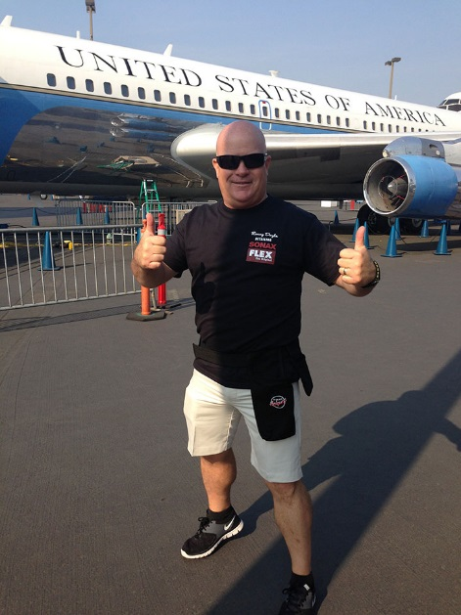
Master detailer/trainer Renny Doyle of Attention to Details & Detailing Success in Big Bear Lake, California leads the largest Air Force One Detailing Team to date in a 2-weeklong mega-detailing event at Seattle’s Museum of Flight Monday, April 11 through Saturday, April 23.
Sixty handpicked technologically advanced detailers from across the country will continue their decade-long preservation of the original Air Force One presidential jet; polish the all-aluminum fuselage of a legendary WWII Boeing B-29 Superfortress bomber; and clean and preserve the paint and bright work on 14 additional priceless aircraft that are now displayed in the new Airpark Pavilion.
Doyle’s famous Air Force One Detailing Team is no stranger to cleaning, restoring, and protecting multi-million dollar museum treasures and rare, exotic, and classic vehicles of all kinds. From vintage firetrucks to Frank Sinatra’s 1976 Rolls-Royce Silver Shadow; Reggie Jackson’s 1963 427 Shelby Cobra; Gordon McCall’s 1937 Fiat 500; and a fleet of Maseratis, Porsches, and Ferraris at Monterey Car Week, Boeing’s Centennial Celebration is Doyle’s most demanding detailing project yet.
“Boeing wants all their aircraft in mint condition for the Centennial so we will be coordinating twice the number of team members (60) as ever before, and working on about 15 multimillion dollar aircraft simultaneously,” says Doyle. “They will come in two, weeklong shifts — Team Alpha and Team Bravo — with Team Centennial consisting of team leaders, supervisors, and veterans of the project who will be onsite for the full run.
“This is by far the most exciting and yet the most challenging project the Museum of Flight has offered us and we are all honored to be tasked with such a prestigious and unprecedented opportunity.”
All AFO Team members own their own successful detailing businesses, and they pay their own expenses and donate their time and skill to the massive project.
Air Force One
Fourteen years ago, a Bush Administration official contacted Doyle about restoring the Boeing 707-120 also known as Special Air Missions (SAM) 970, the first Air Force One jet, which was a flying Oval Office for Presidents Eisenhower, Kennedy, Johnson, and Nixon. It also entertained many international VIPs such as Nikita Khrushchev and Henry Kissinger.
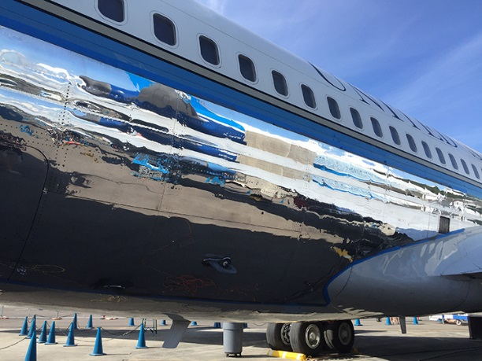
Shocked by the call, Doyle thought at first it was a prank until he saw the neglected jet displayed on the open tarmac exposed to Seattle’s notorious climate. It had not been cleaned in many years and he knew it would take several years to bring it back to as close to its natural glory as possible.
In the past two years, the Team has entered into a “preservation” rather than restoration stage with the plane. Just this year, with the opening of the museum’s new covered hangar, AFO has found a protective home, but it still requires an annual cleaning and polishing and is officially the Air Force One Detailing Team’s responsibility to maintain over the next five years.
WWII B-29 Superfortress Bomber
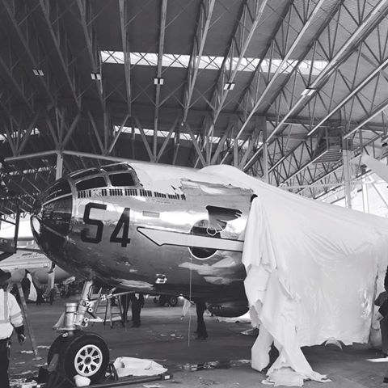
Also known as T-Square 54, this WWII workhorse is scarred with holes where fifty-caliber bullets raked her aluminum skin flying sorties over the Pacific and Japan before being abandoned for many years in the Arizona desert. When the Museum of Flight saved her and brought her to Seattle, the 2011 Air Force One Detailing Team polished her bright work for the first time since the 1940s.
“After five years, she isn’t in nearly as bad condition as she was when we tackled her in 2011,” says Doyle. “But that aluminum gets chalky in a short amount of time and we will have to use a heavy metal polish to bring back that perfectly mirrored surface.”
About Renny Doyle
In 2013, Air Force One was the 4,000th airplane Renny Doyle had detailed. Known as the Detailer of Air Force One, he selects only the very best and most meticulous detailers from his worldwide detailing network known as the Detailing Success Network. His Detail Mafia are the most senior-level members of the overall network who have trained and worked with him over the past 30 years.
Often seen conducting seminars and holding demonstrations at automotive trade shows like SEMA and the Mobile Tech Expo, Renny travels the world sharing his high-end detailing expertise and searching for innovative new products, equipment, and detailing techniques; as well as ways to do it better and more efficiently.
In partnership with San Francisco-based P&S Sales, Renny Doyle is launching a new line of detailing products called Double Black, the Renny Doyle Collection later this spring, as well as launching three new training facilities across the country. He also has a best-selling book available at Amazon entitled How to Start a Home-based Car Detailing Business. Doyle and his Air Force One Detailing Team are the rock-stars of the detailing industry nationwide.
For more information about this year’s Boeing Centennial mega-detailing event at Seattle’s Museum of Flight, contact Diane Doyle at (909) 366-0909, or Kimberly Ballard at (256) 653-4003.

