<Media Kit>
HankookNFC Introduction

- Development of card-touch simple payment system using NFC function of smartphone
- Credit card touch or fingerprint authentication without personal information input
- Development of payment service for Samsung Pay through phone 2 phone touch
- Development of the fastest and easiest global mobile POS platform, Snappywire

- About Us
Company Name: HankookNFC Co., Ltd.
Established: April 1, 2014
CEO: Hwang, Seugik
Homepage: http://www.hankooknfc.com
Facebook: https://www.facebook.com/nfcpay

HankookNFC is a leading company in financial technology that provides proprietary NFC applied payment transaction technology and a mobile payment platform. Since the beginning of 2014, it has focused exclusively on payment and authentication with its patented NFC technologies. Hankook NFC has been providing a unique payment service in Korea, named PayApp that enables small/individual sellers to accept credit cards or mobile payments through their mobile. Currently, Hankook NFC is making its utmost efforts to expand its service worldwide. SnappyWire, the global target branded service, is to be launched in the US market in September 2018. Hankook NFC will always do its best to create a new way of shopping and lead the cashless society

- Service Introduction

Service Name: SnappyWire (MWCA Exhibit)
service information :
SnappyWire is a fast and easy mobile POS platform service that allows self-employed, small merchants, or individuals to make payments on their smartphone with credit cards or Apple Pay. With the SnappyWire app on merchants’ smartphone, they can sell their product online anytime and anywhere, and they can upload and sell stuff through the social media network supported by SnappyWire. Without creating an online shopping mall, our user can simply take a picture of the product and upload it on their Facebook or other social media to receive the payment for the product. It is a breakthrough service that can be done. SnappyWire offers a convenient mobile payment service that allows you to use various payment methods such as credit card touch, phone 2 phone, credit card scanning method, OR barcode payment, URL link method.

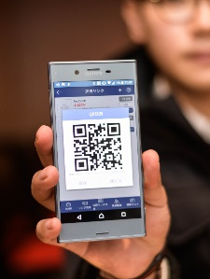
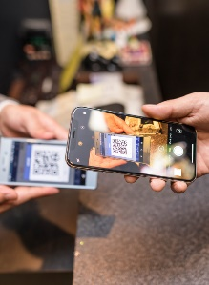
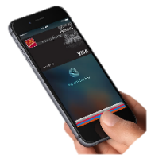


< Apple Pay process in SnappyWire >

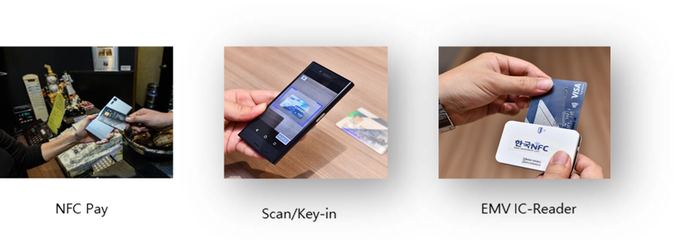
< various payment methods in SnappyWire >

SnappyWire Features:
Apple Pay
Snappywire’s one time QR code to your customer makes you accept Apple Pay payment. By just scanning the QR code with your iPhone, customers can pay with Apple Pay fingerprint or FaceID.
Demonstration video : https://www.youtube.com/watch?v=dzH1ToIbMyA

NFC Pay
Just placing your customer’s credit card to the back of your NFC-enabled smartphone receives credit card payments. EMV contactless cards, Visa PayWave and Mastercard PayPass are supported.
Demonstration video : https://www.youtube.com/watch?v=ZHzIxUZNv6w

Snappy Link
Creating a payment link through SnappyLink feature will sell your items on all your social media network. Sell online instantly without having to create online shopping website!
Demonstration video : https://www.youtube.com/watch?v=xNfGmUyTmOE

Scan/key-in
Credit card payment by either OCR scanning your customer’s credit card or manually key-in information makes transaction completed.
Demonstration video : https://www.youtube.com/watch?v=zbGY1FAL_-Y

EMV IC Reader
Connecting a Bluetooth-enabled IC card reader can take credit card payments.
Demonstration video : https://www.youtube.com/watch?v=ibebLFeougc

SnappyWire’s key benefits :

o. Your phone becomes a payment terminal by just installing SnappyWire app on your smartphone ; No extra hardware is necessary.
o. Our global partner, Stripe's payment processing system process the payment in a secure and accurate way.
o. Can make online/offline transactions at any situation.
o. Various payment methods : Apple Pay, NFC Pay, Snappy Link, EMV IC-Reader, Scan/Key-in
o. Simple social media log-in and merchant account application process.
o. Invoice and receipt can be sent to an email or saved as an image document.
o. No set-up or monthly fee, no maintenance cost.
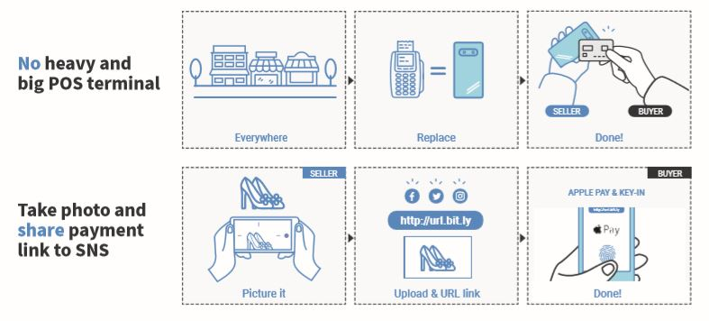
<Reference image -1 SnappyWire key features in service >
Service Name: NFC Easy Payment
Service Description: NFC Easy Payment is a mobile easy payment service that uses smart phone NFC function and post-payment traffic card function without entering and storing card information and personal information.
Users do not need to install a separate payment app where mobile payment is required, such as shopping malls, and they can complete the payment by touching the back of their smartphone with a post-payment traffic card without storing their card information or authenticating their personal information. In particular, since NFC Easy Payment does not store card information or personal information, more secure mobile electronic payment is possible out of the risk of leakage, hacking of card information and personal information.

Related patent: 'Self-card payment system using mobile communication terminal and its method' (Patent No. 10-1333230)
Demonstration video: https://youtu.be/PTcHXOOIFlo

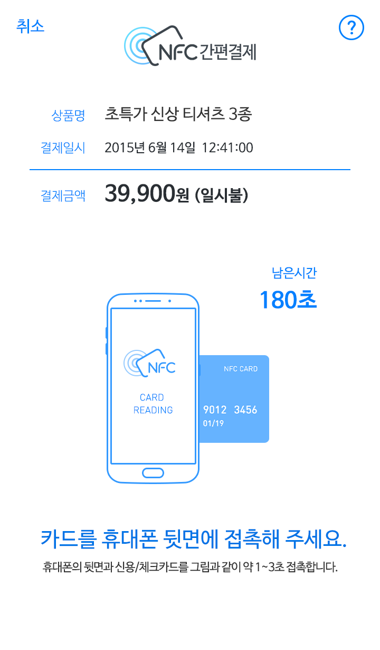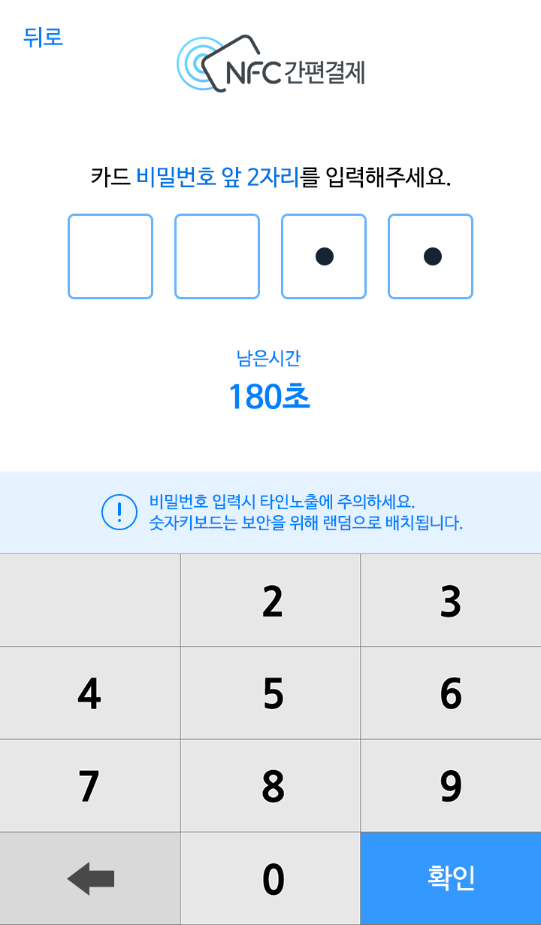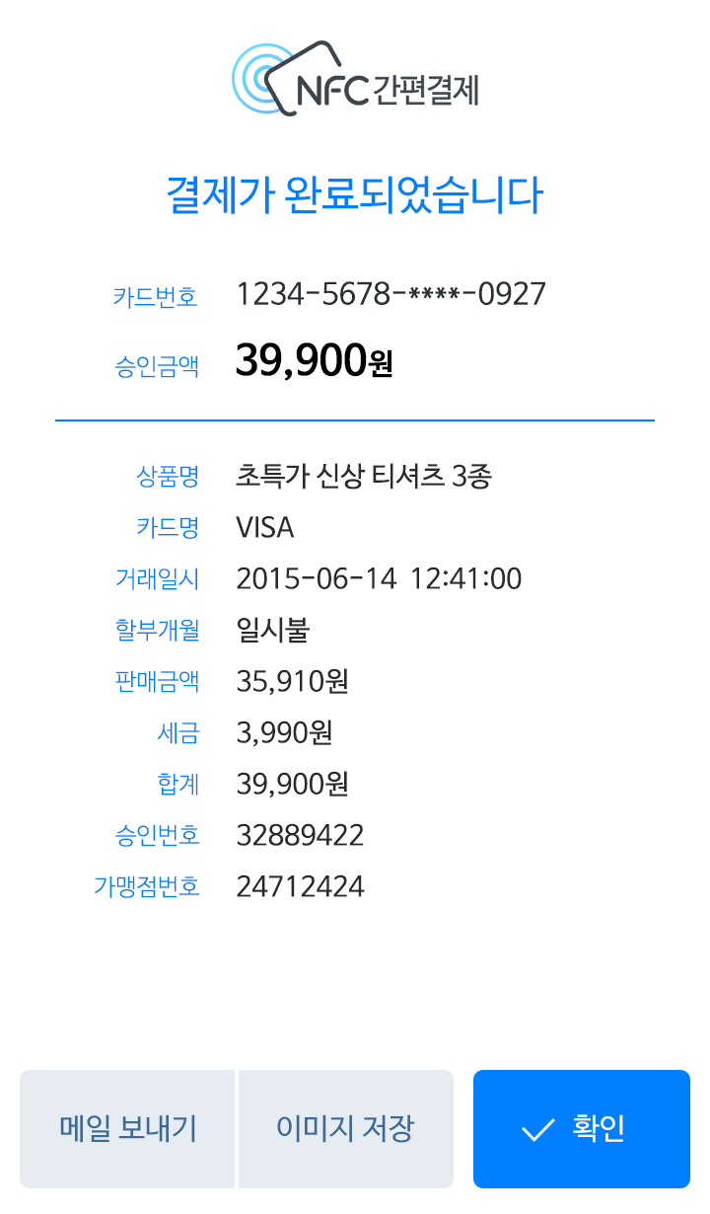
< Reference image -2 NFC Easy Payment App>

Service Name: Phone 2 Phone Payment
Service contents: Phone 2 phone payment is a payment service using Samsung Pay. It is a simple payment application that can be used for small business owners and delivery and door-to-door sales man. It utilizes phone 2 phone payment, payments can be made by phone with Samsung Pay or EMV standard contactless cards (Visa Paywave, Master Paypass).

Demonstration video: https://youtu.be/LR09molk_lk
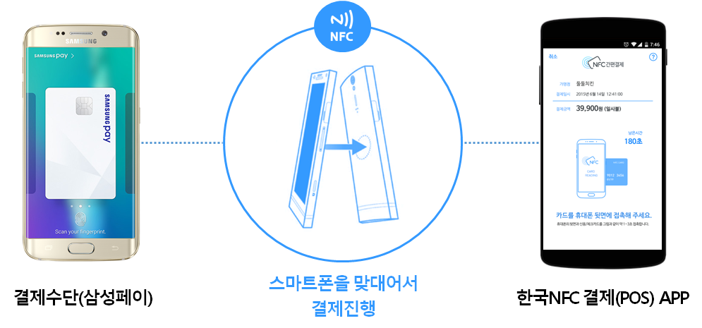
Hankook NFC App (Seller)

Samsung Pay (Buyer)

Phone 2 Phone
< Reference image -3 Payment Process of Phone 2 Phone>

Service name: NFC card touch authentication
Service contents: NFC card touch authentication is an authentication service that utilizes a smart phone that supports the post-paid traffic card (credit / check) and NFC function, and touches the user's smartphone. This is a service to complete your certification with NFC touch and secret number.
This service is designed to allow users to directly touch a smart phone with a physical card that is physically separated and to enter the 2-digit card password of the user. It also provides a wide range of applications for verifying the identity of users and whether they are authenticated by users such as financial institutions, government offices, games, portal sites, and shopping malls.
Related patent: 'Simple personal authentication system and method using mobile communication terminal and physical financial card' (Patent No. 10-1512001)
Demonstration video: https://youtu.be/S96DuUzMlXQ
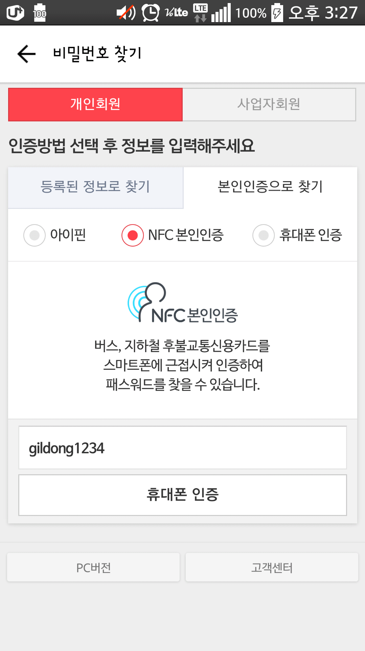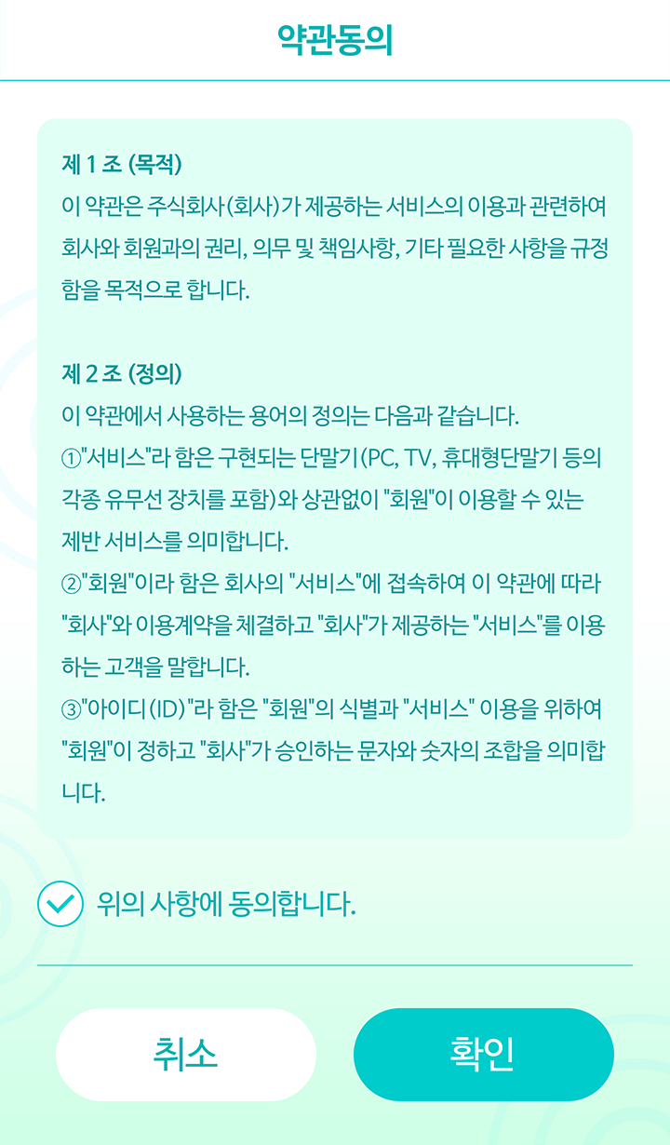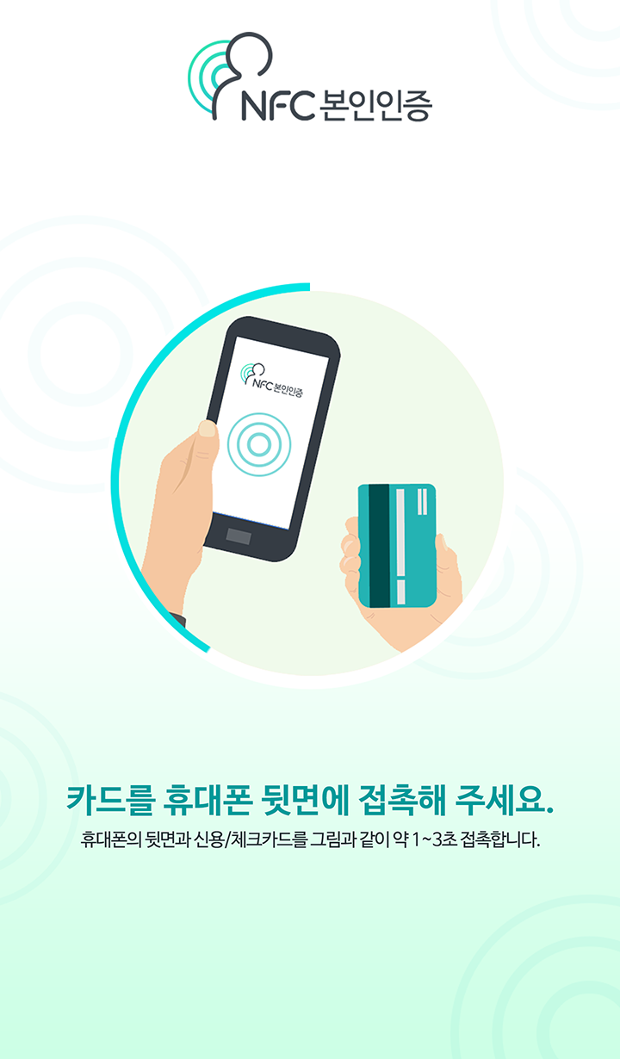
< Reference image -4 NFC card touch authentication app>

