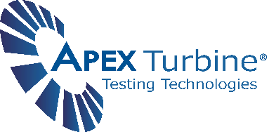
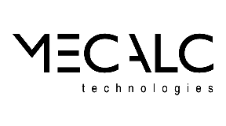

Contact Info:
Jeremy Farmer
(931)486-0081
info@apexturbine.com
www.apexturbine.com
FOR IMMEDIATE RELEASE

APEX and MECALC Announce Collaboration

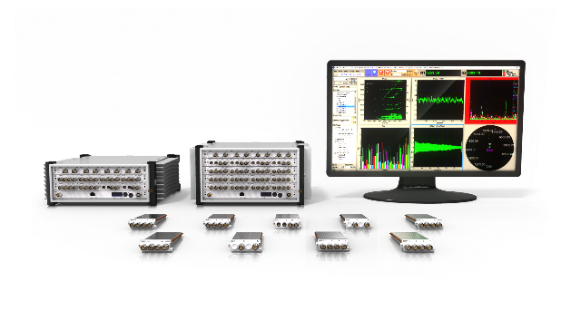
Spring Hill, TN - APEX Turbine Testing Technologies, Inc. and MECALC Technologies, Inc. are pleased to announce a partnership to deliver integrated dynamic data acquisition systems (DDAS) featuring the DS software application from APEX Turbine and a variety of MECALC signal conditioning and digitizer products. The agreement allows both companies to offer fully integrated solutions worldwide.
MECALC QuantusSeries Hardware

“Through MECALC, we can provide our customers with an assortment of data acquisition hardware choices that in turn allow APEX to deliver a more personalized testing solution”, said Dr. Kurt Nichol, President and CEO of APEX. “We see this consistently with our customers, they require the flexibility to mix and match a variety of digitizers and signal conditioning. The combination of our software with MECALC hardware is yet another example of our commitment to providing customers with the widest variety and highest quality dynamic data acquisition solutions in the industry.”
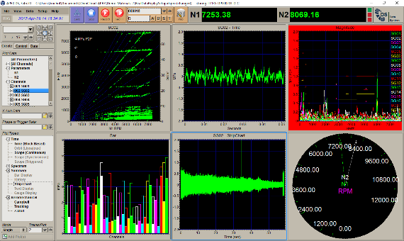
APEX DS-Dynamic Data Acquisition Software
MECALC offers a wide array of highly modularized hardware devices, ensuring support for all types of measurements required by the turbomachinery industry.

“Our partnership with APEX provides advanced solutions for our customers in turbine test and analysis”, said Cara Klintworth-Watt, President of MECALC. “The combination of QuantusSeries acquisition and signal processing frontends with APEX’s DS application provides a complete solution from accurate signal acquisition to a complete fully-featured testing environment. APEX offers a networked architecture for flexibility and large channel counts. High and low-speed data streams are seamlessly integrated for online analysis and data storage. In real time, data is streamed to multiple stations for monitoring and analysis.”

By combining MECALC hardware with APEX Software, customers now have one solution for data acquisition, supporting applications that require rugged, portable handheld systems as well as large portable and rack-mounted systems for higher channel counts. This collaboration between APEX and MECALC also provides complete customer support, including global on-site ISO 17025 calibration as well as full system functionality tests.

For more information about these solutions visit
https://quantusseries.com/index.php
https://apexturbine.com/data-acquisition/

About APEX

APEX is a supplier of turbomachinery test and analysis solutions with a proven record of delivering integrated, reliable, industry-leading software applications worldwide. Our company operates under the highest ethical standards and is dedicated to customer satisfaction by delivering what we promise and servicing what we sell. Our goal is to not only be a reliable supplier, but also a test partner for our customers.

At APEX, we bring our years of industry knowledge and experience directly to you through the many solutions we provide. Our consultants and products address every phase of turbomachinery vibration test and analysis to increase your overall efficiency, effectiveness and success.

About MECALC

Since 1984 MECALC has designed, developed, and manufactured advanced data acquisition and control systems. Our instruments provide integrated, open architecture for the measurement of sound, vibration, fatigue, temperature, high-speed voltage, and more. Our solutions fulfil any measurement need, from portable data recording, troubleshooting and distributed systems, to large rack-mountable applications.

Forward-thinking design, a strong modular upgrade strategy and in-depth experience in Test and Measurement allow us to deliver the right balance between staying on top of technological advancements and ensuring longevity of investment.

