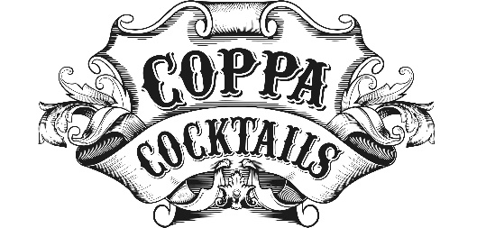
PR Contacts:
Deussen Global Communications, Inc.
New York, NY
Alejandro Vich
avich@deussenglobal.com

M.S. Walker Brands
Boston, MA
John LeRoy
jleroy@mswalker.com

About Coppa Cocktails®, “The World’s Best Cocktails”
This robust line of award-winning, classic to contemporary premium pre-mixed cocktails was developed by Toorank International Spirits, a Dutch distilling and bottling company founded in 1978. Today, Coppa Cocktails are currently available in more than 30 countries. With natural flavors, premium spirits, and disruptive packaging, Coppa Cocktails appeal to the modern consumer who seeks high quality, convenience, and aesthetic appeal.
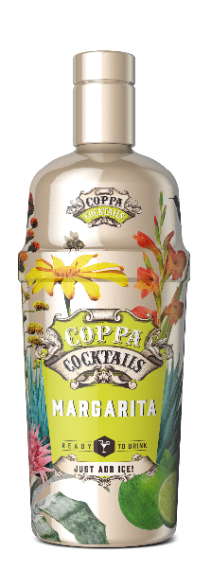
About Coppa Cocktails Margarita: Made with Tequila, orange liqueur, lime, and natural flavors, its distinct yet smooth agave aroma is followed by a tart, refreshing palate. No blender, no problem: just add ice!

- SRP: $17.99
- ABV: 15%
- Where to Find in the U.S.: Distributed in 27 states
- Website: Coppa Cocktails Homepage
- Socials
  - IG: @coppa_cocktails #CoppaCocktails
  - FB: @CoppaCocktailsGlobal

Coppa Cocktails’ Cosmopolitan, Long Island Iced Tea, Mai Tai, Rum & Ginger, Sex on the Beach, and Tequila Sunrise are also currently for sale in the U.S. All Coppa Cocktails are non-GMO.
Imported by M.S. Walker Brands: Founded in 1929 in Boston, Massachusetts, and still based there, M.S. Walker Brands acts as an importer of curated nationally marketed spirit and wine brands from around the world, in addition to producing its own internationally marketed spirits brands.
Please enjoy responsibly.
Media samples, hi-res lifestyle imagery, video, and interviews available upon request.

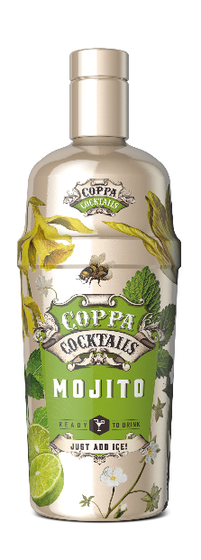About Coppa Cocktails Mojito: Made with premium Caribbean white rum, lime, and mint, it has prominent initial aromas of fresh and sweet mint leaves, followed by a palate led by refreshing sour lime.

- SRP: $17.99
- ABV: 15%
- Where to Find in the U.S.: Distributed in 27 states
- Website: Coppa Cocktails Homepage
- Socials
  - IG: @coppa_cocktails #CoppaCocktails
  - FB: @CoppaCocktailsGlobal

Coppa Cocktails’ Cosmopolitan, Long Island Iced Tea, Mai Tai, Rum & Ginger, Sex on the Beach, and Tequila Sunrise are also currently for sale in the U.S. All Coppa Cocktails are non-GMO.
Imported by M.S. Walker Brands: Founded in 1929 in Boston, Massachusetts, and still based there, M.S. Walker Brands acts as an importer of curated nationally marketed spirit and wine brands from around the world, in addition to producing its own internationally marketed spirits brands.
Please enjoy responsibly.
Media samples, hi-res lifestyle imagery, video, and interviews available upon request.

