FOR IMMEDIATE RELEASE
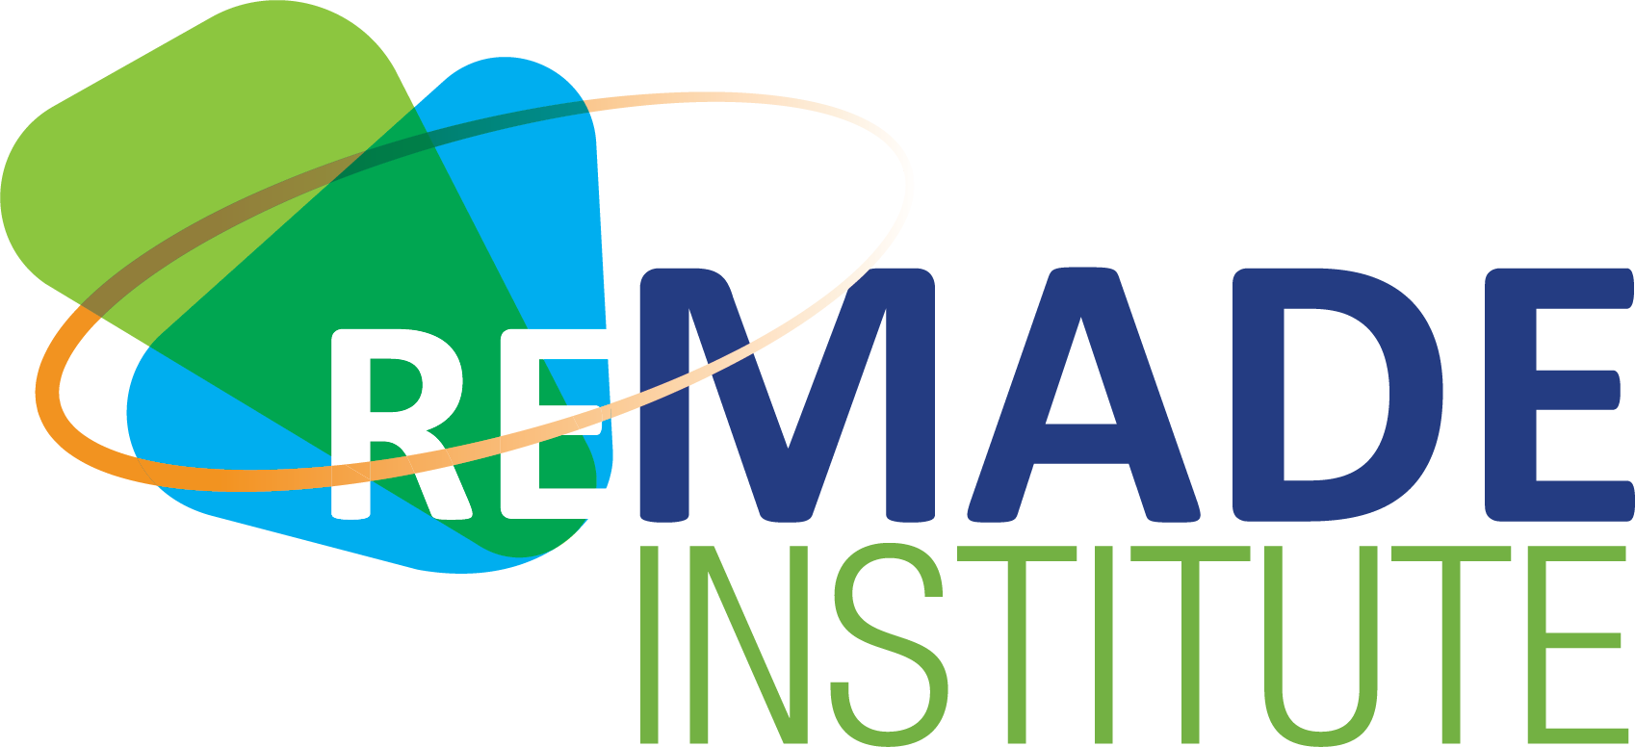

Contact: David Mancuso, Marketing and
Communications Manager
Phone: 585-213-1034
Email: dmancuso@remadeinstitute.org

The REMADE Institute Announces 12 New Projects
Investment of $5.9M aimed at improving competitiveness of U.S. manufacturing

Rochester, NY – May 7, 2019 – Today, the REMADE Institute announced the selection of 12 projects dedicated to improving the competitiveness of U.S. manufacturing. Magdi Azer, REMADE’s Chief Technology Officer, stated, “The selection process was highly competitive. We received many comprehensive submissions that addressed our technical focus areas. Ultimately, these 12 projects totaling $5.9 million in public-private investments were selected.”

These projects further REMADE’s mission to develop innovative and cost-effective technologies to reuse, remanufacture, and recycle metals, fibers, polymers and electronic waste. “These 12 projects truly represent the best of REMADE – uniting 25 industry innovators and academic researchers - all dedicated to transformational projects focused on sustainable manufacturing and recycling,” said Nabil Nasr, CEO of the REMADE Institute.

The projects will explore ways to help U.S. recyclers remain competitive amidst global scrap market disruptions, develop new design tools and remanufacturing processes to increase material recovery at the end-of-life, increase the recycling rate of plastics, paper, rubber, and e-waste, and then utilize these recycled materials to manufacture products. For project descriptions, visit our website at www.remadeinstitute.org

Founded in May 2017, and partially funded by the U.S. Department of Energy, REMADE is a Manufacturing USA® institute. In partnership with industry, academia and national labs, the REMADE Institute enables early-stage applied research and development of technologies that could dramatically reduce the embodied energy and carbon emissions associated with industrial-scale materials production and processing.

Efficiencies gained from these technologies have the potential to save 400 TBtus of energy, improve U.S. economic competitiveness through innovative new manufacturing techniques and offer new training and jobs for American workers.

In total, the REMADE Institute has 31 projects selected for award, totaling nearly $15 million in value.

###

