*FOR IMMEDIATE RELEASE*

Gabrielle Terese Modern Portable
gabby@modernportable.com

“Small music system is a really big deal!”
-Don Lindich, Sound Advice/Tribune Media Service

San Francisco, CA – November, 22th 2017: Introducing the brand new, highly acclaimed HIFI MC Micro Music System by Modern Portable.

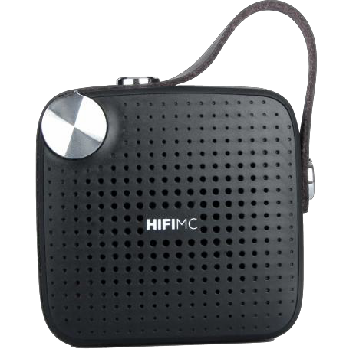
The HIFI MC Micro Music System by Modern Portable is much more than just a Bluetooth Speaker. It’s a complete music system that also includes an FM radio, a media player that plays songs from removable flash memory, and an auxiliary
connection. Best of all, it sounds great, it's surprisingly loud, it's small enough to fit in your pocket, and it costs less than $30 – the price of an ordinary, one-trick-pony Bluetooth speaker.

“With its retro-inspired style and tiny size, volume dial, good sound, multiple ways to listen, and easy and reliable operation, the HIFI MC Micro Music System is the most satisfying $30 product I have tried in a long, long time. It also has a quality feel and unmistakable charm that makes it cool, desirable and fun." Don Lindich, Sound Advice/Tribune Media Service (a nationally renowned tech columnist, read by millions worldwide)

Don’t settle for a simple Bluetooth speaker when you can get so much more with this pocket-sized, immersive, and full-featured music system.

Though small, the HIFI MC Micro Music System sounds big, with deep, powerful bass and surprisingly loud volume. When you hear the HIFI MC Micro Music System, your eyes will not believe what your ears are telling you.

HIFI MC Micro Music System Features Include:

- Full Bluetooth functionality for wireless audio from all Bluetooth enabled devices
- Astonishingly loud, big sound
- Pocket sized, ultra light weight design
- Premium distorsion free sound & deep rich accurate bass
- Long lasting rechargeable battery life
- IPX4 - Water resistant level
- Integrated FM Radio
- Integrated Micro SD media player
- Wired / Line-In audio playback
- Integrated premium leather carrying strap
- Retro volume dial for percise audio volume adjustment
- IN THE BOX: HIFI MC, Micro USB charging cable and Micro to Auxilery Line-In Cable

Pricing and Availability: The HIFI MC Micro Music System is available now for only $29.99. The HIFI MC are sold at ModernPortable.com, Amazon.com, Walmart.com and select Modern Portable authorized dealers. Additional information can be found at ModernPortable.com

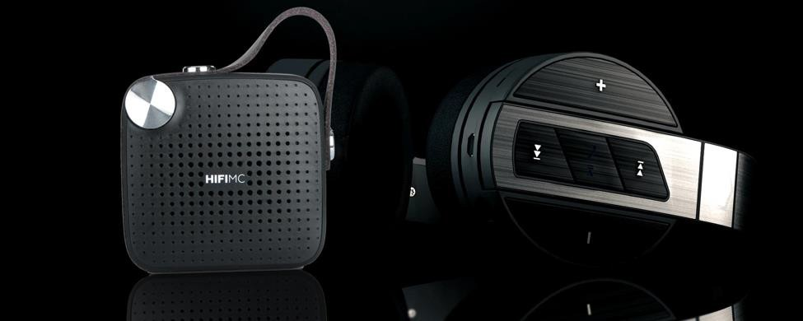

Why has Modern Portable emerged as a serious threat to the Industry? Five ideals have enabled Modern Portable to become one of the fastest growing direct to consumer companies in the industry:

Modern Design: Our products feature a modern design that is clean, attractive and functional. Our eye-catching products stand out in a sea of look-alike competitors, and the look, feel and operation will delight you.
Modern Performance: All Modern Portable products provide outstanding performance that leads at their price points, and compare favorably to much more expensive products. We thoroughly engineer everything with top performance in mind, and then use the best factories for manufacturing. When you purchase a product from Modern Portable, quality and performance is assured.
Modern Value: Our products lead at their price points, and compare favorably to much more expensive competitors. Our value equation is unmatched in the industry.
Modern Efficiency: An efficient and eco-friendly philosophy drives everything we do. We save money and raw materials with our attractive yet minimalist packaging, and a PDF instruction manual for your product is sent to you when you complete your order. When many thousands of products are shipped, the savings in weight and bulk are considerable. Not only does this reduce our cost, so we can pass the savings to you, the environment is protected as well. Our approach uses less energy to transport the product from the factory to our warehouse and from our warehouse to your doorstep.
Classic Service: At Modern Portable, we care! We are committed to always doing the right thing for our customers, from designing the best products in their class, manufacturing them to high standards of quality, and pricing them fairly so everyone can afford them. Once you are our customer we will take a personal interest in your satisfaction, with the goal of building a long- term relationship like people used to have with their local general store. Our products will bring you in, and our staff and service will keep you as a happy customer.

