PRI·MED Medical Products Announces New Medical PPE Manufacturing Facility in Laos

Located in Vientiane, the New Facility is Expected to Open by 2021

EDMONTON, Alberta, June 25, 2020 — Edmonton-based PRI·MED Medical Products, a worldwide leader in manufacturing single-use medical personal protective equipment (PPE) including face masks, gowns and examination gloves – has today announced the development of a new manufacturing facility in Vientiane, Laos. The new location broke ground in February 2020, and is expected to be operational in the first half of 2021. The development and construction is wholly-owned by PRI·MED. When complete, it will employ an estimated 300+ people in a 95,000 square foot facility.

“The Government of Canada is pleased to see another substantial, long-term investment in Laos by a reputable Canadian firm with a successful track record,” said Dr. Sarah Taylor, Ambassador of Canada to Laos. “With its manufacturing know-how and socially responsible business practices, PRI·MED is exactly the kind of quality investor Laos has been seeking to diversify its export production and tap into global value chains.”

PRI·MED has successfully operated Wholly Owned Foreign Enterprises (WOFEs) in China since 2007, employing close to 900 workers and providing high-quality medical products to their global customer base. In recent years, due in part to its membership in the ASEAN Economic Community, Laos has emerged as one of the fastest-growing locations for foreign-operated manufacturing, primarily in exports of electronics, telecommunication and electrical equipment. The value of manufacturing exports nearly tripled in the five years between 2013 and 2017 from USD$270 million to USD$780 million.

“Our new Laos manufacturing facility affirms PRI·MED’s commitment to our continued global leadership in the manufacturing and supply of high-quality face masks and isolation gowns,” said David Welsh, President and CEO of PRI·MED. “COVID-19 is reaffirming the significance of a diversified supply chain. Vertical integration of key input materials and expanding our manufacturing footprint are important strategies in strengthening PRI·MED’s supply chain continuity.”

Founded in 1995, PRI·MED has established itself as the leading supplier of personal protective equipment (PPE) in Canada. The company’s products are found in nearly every hospital in Canada as well as hundreds throughout the United States, Europe, Asia, South Africa, Australia and New Zealand. For three years running (2018, 2019, 2020), PRI·MED was recognized by professional services network Deloitte as one of “Canada’s Best Managed Companies.” It was also selected in 2018 and 2019 as one of “Alberta’s Top 75 Employers” by Mediacorp Canada.

---

Media Contact:
Craig Blackburn, Senior Manager, Brand and Engagement
Email: Craig.Blackburn@PRIMED.ca

PRI·MED Medical Products
#200, 2003-91 Street SW
Edmonton, Alberta T6X 0W8
Phone: 780 497 7600
Web: https://PRIMED.ca

About PRI·MED Medical Products:
PRI·MED Medical Products Inc. is a dynamic, global medical product manufacturer specializing in high-quality personal protective apparel. On a mission to protect people from harmful substances and infectious disease, PRI·MED is a leading Canadian provider to hospitals, clinics, labs and long-term care facilities, and offers branded, co-branded and private label products and services to its customers and international partners.

Tags: #laos, #vientiane, #edmonton, #alberta, #canada, #healthcare, #medicalproducts, #PPE, #manufacturing, #facemasks, #medicalfacemasks, #manufacturing, #covid-19

Photos:

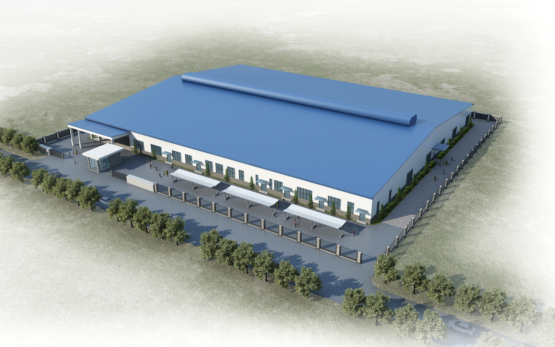
3D Rendering of PRI·MED’s Manufacturing Facility in Vientiane, Laos

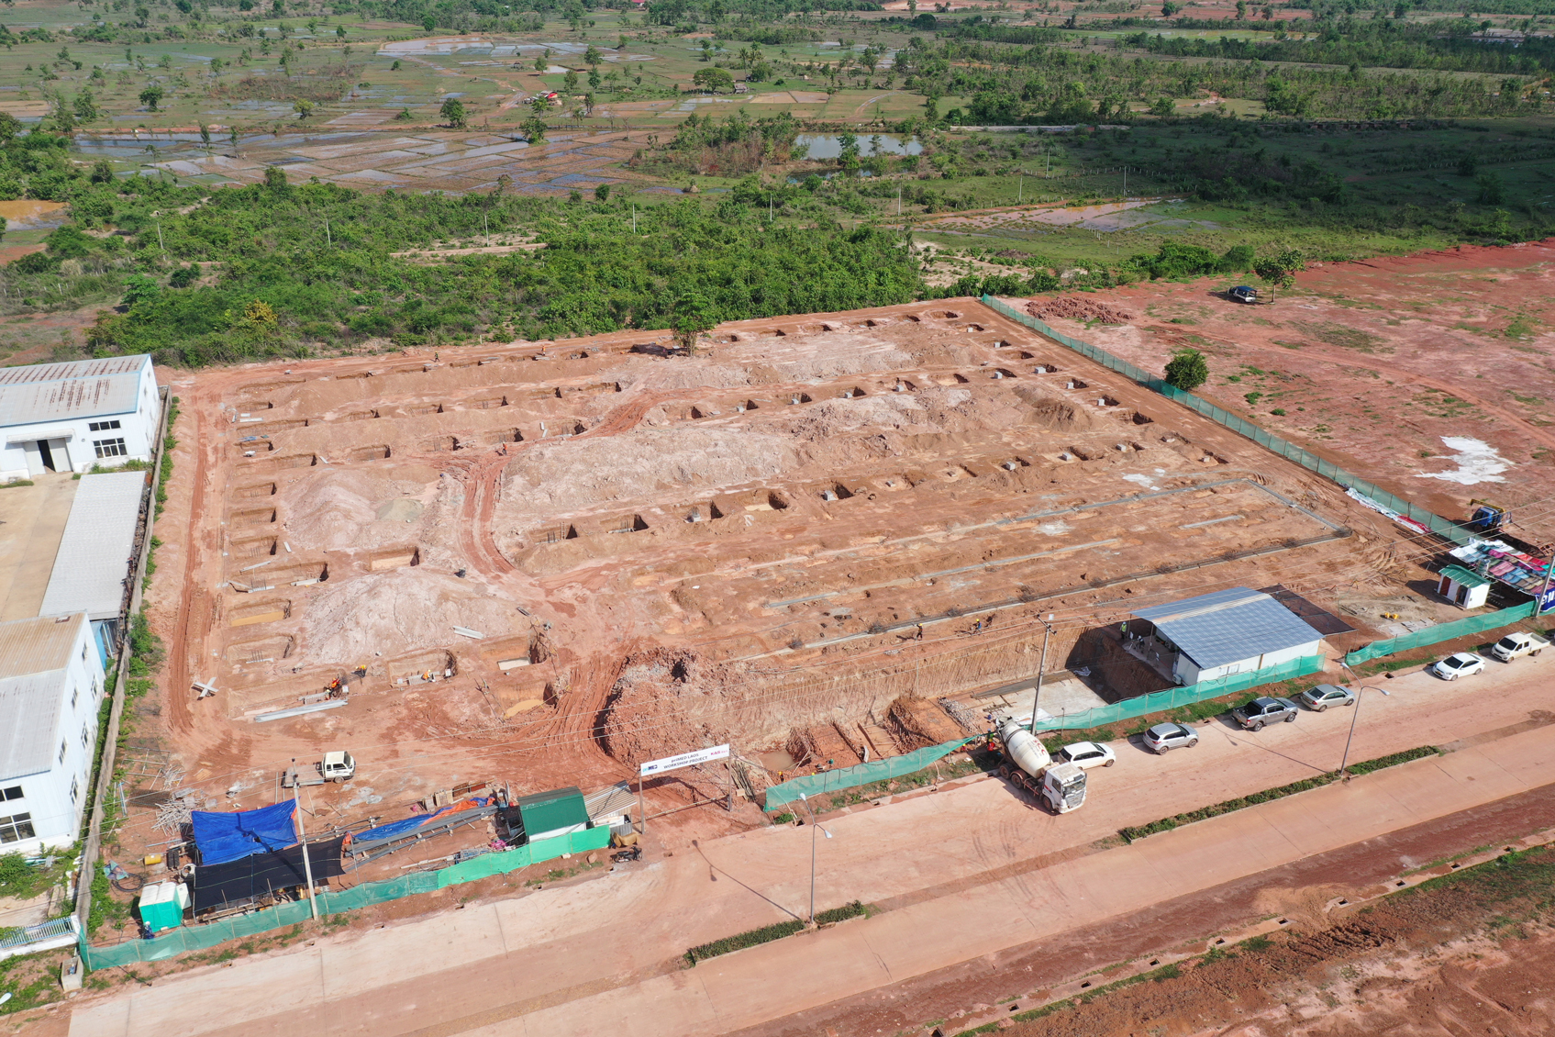
Bird’s Eye View of Facility Construction Underway in Vientiane, Laos

Captions:
“With its manufacturing know-how and socially responsible business practices, PRI·MED is exactly the kind of quality investor Laos has been seeking to diversify its export production and tap into global value chains.”

“Our new Laos manufacturing facility affirms PRI·MED’s commitment to our continued global leadership in the manufacturing and supply of high-quality face masks and isolation gowns.”

