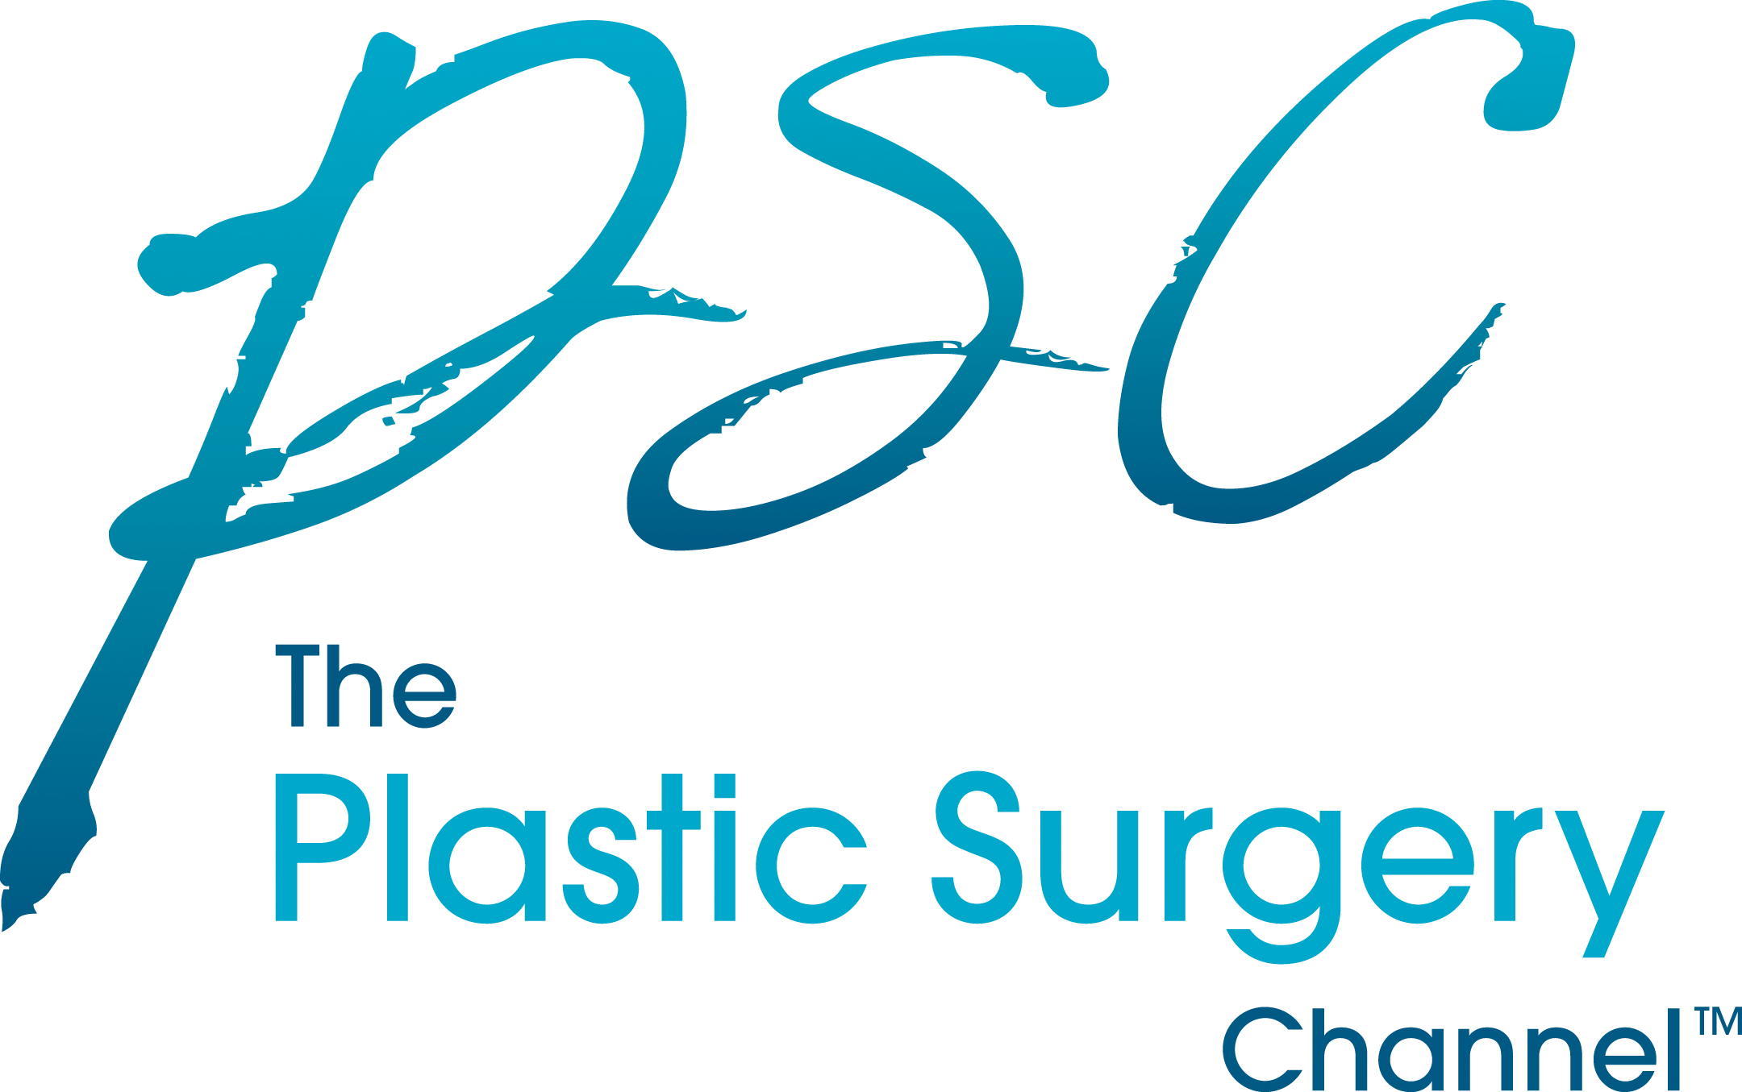
FOR IMMEDIATE RELEASE
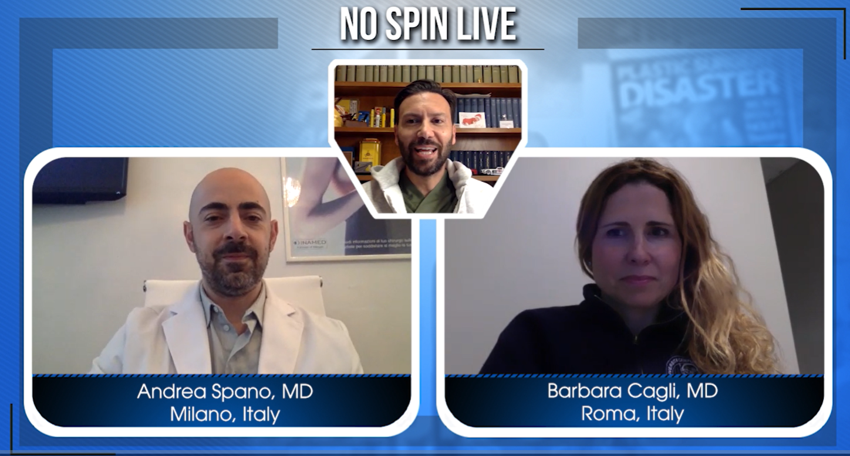
DALLAS, TX – (June 5, 2019) -- The Plastic Surgery Channel, LLC, has announced the launch of their new, exciting program No Spin Live – ITALY! The PSC has taken virtual programming International allowing a platform for the hottest, trending topics in plastic surgery to be discussed in real time. This new video format allows viewers access to the BEST Experts worldwide. No Spin Live - - ITALY provides viewers more engagement and a convenient way to explore the most up-to-date information in plastic surgery news and procedures.

“Delivering high-quality, reliable information without marketing spin is the new direction in our field,” says President and CEO of The PSC, William P. Adams, Jr., MD. “Patients crave credible information, but it’s often difficult to discern in today’s heavily marketed medical field. The Plastic Surgery Channel contributing surgeons are global educators and also some of the most prominent, board certified plastic surgeons in the world,” says Adams.
The premier episode of No Spin Live –ITALY features three prominent experts in the field of plastic surgery. Hosted by Dr. Adriano Santorelli , of Naples, Director of Academy of Aesthetic Sciences Napoli, Honorary Lecturer Queen Mary University of London, www.adrianosantorelli.it, and expert medical analysts Dr. Andrea Spano of Milan, Director of the Clinic Milano, Consultant of Istituto Nazionale Tumori, www.dottorspano.it and Dr. Barbara Cagli, MD, PhD, of Rome, Campus Bio Medico University of Rome, Italy, www.policlinicocampusbiomedico.it.
Drs. Santorelli, Spano and Cagli tackle trending topics like rinofillers, glueteoplasty with hyaluronic acid and the latest in simulation 3D in this premier episode.
“Virtual filming and programming is one of the best ways to keep up with the latest information and techniques in plastic surgery,” says Dr. Adams. The Plastic Surgery Channel has developed a high-level process of gathering the top news in plastic surgery. “Virtual filming and Live streaming keep us on top of the latest trends and procedures and with our new programs, like No Spin Live and video technology, we can now produce and distribute educational information more efficiently.” The Plastic Surgery Channel publishes new written and video content multiple times weekly and all content is vetted by board certified plastic surgeons worldwide.
About ThePlasticSurgeryChannel.com
The Plastic Surgery Channel™ (PSC) is a trusted resource for patients desiring credible and informative information about plastic surgery. The PSC produces and distributes timely and educational programming at the peak of relevance, without the interference of marketing bias.

You can visit The Plastic Surgery Channel online at: http://www.theplasticsurgerychannel.com

Media Contact:
Patrice Khunteyev, Patrice@theplasticsurgerychannel.com

