Rhino Tool House Media Contact
Steven Vogt
Phone: 262.710.4191
Fax: 262.796.1194
Email: steven.vogt@rhinotoolhouse.com

Press Release

Rhino Tool House is Proud to Announce a New Strategic Partnership with PINpoint Information Systems

CONCORD, NC February 16th, 2021: Rhino Tool House, a family of brands dedicated to quality, safety, productivity and innovation, is proud to announce a new Strategic Partnership with PINpoint Information Systems.

At Rhino Tool House, our mission is to identify and deliver the world’s most innovative manufacturing solutions, providing superior service with local expertise, all to empower our customers to be more productive, build a better-quality product, and maintain a safe environment for their workers.
“We are excited to partner with PINpoint. This partnership will help our manufacturing customers accelerate their digital transformation and dramatically improve the quality and efficiency of their manufacturing operations.” – Dan Brooks, CEO, Rhino Tool House.
“PINpoint is excited to partner with Rhino Tool House. The combined expertise of both organizations will help customers accelerate their Industry 4.0 journey and drive new levels of quality and efficiency.” – Don McCartney, CEO, PINpoint Information Systems.
PINpoint’s leading edge MES Solution is used by global manufacturers to build high quality products more efficiently. By combining PINpoint’s V5 MES software with targeted services, PINpoint helps customers:
- Establish a plan and stay on schedule
- Enforce a repeatable process to build quality products and
- Create a rich data set to drive continuous improvement initiatives

PINpoint’s V5 MES includes the revolutionary 5-Bucket model for tracking how time is spent on the assembly line. This model captures every second of time for every operator and categorizes that time in distinct value-add and non-value add states. The data can then be analyzed to reveal hidden inefficiencies and has been instrumental in helping customers achieve new levels of productivity and performance improvement.

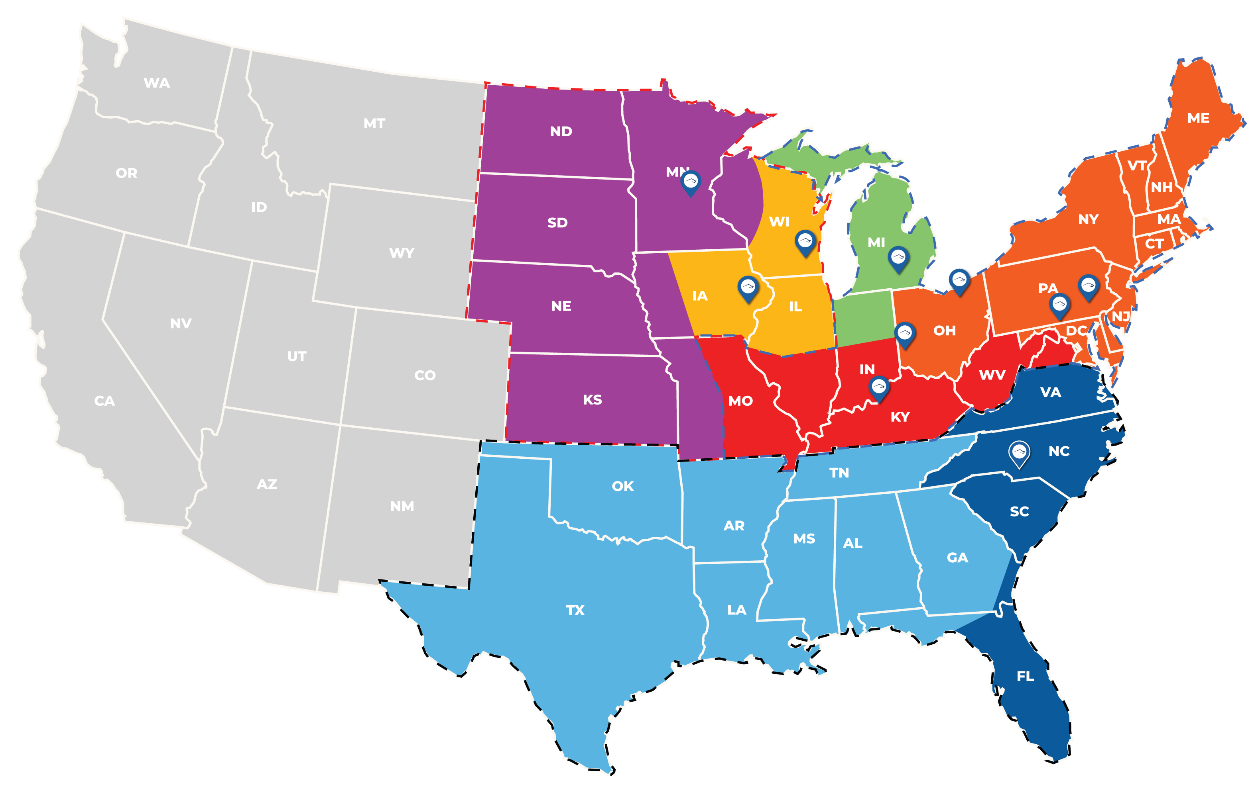
Regional Sales Map

About Rhino Tool House:
Rhino Tool House is an organization born of like-minded businesses dedicated to providing the highest level of detail, service, and support for the industrial market. We continue to expand our footprint, our product and service offerings, and our expertise through strategic acquisitions, hiring and developing the most experienced personnel in this space, and a persistent ambition to be best partner for our customers anywhere in the industrial market.
Our key areas of focus include assembly, industry 4.0, material handling, automation and robotics, error proofing, wearable technology, custom solutions, pumps and hydraulics, as well as service and calibration services for everything we offer.
Rhino Tool House Family of Companies:
www.rhinotoolhouse.com
www.rhinoassembly.com
www.toolhse.com
www.katechnologies.us
www.excelairtool.com
www.buckeyetools.com
www.hovairauto.com
www.gdhoist.com
www.fxdtorquetools.com
www.ramservicegroup.com
www.ctrtoolservice.com

Certifications:
ISO 9001:2015
ISO 14001:2015
ISO 17025: 2005, 2017 Accredited Service Centers

About PINpoint Information Systems
At PINpoint, we believe ‘that action rooted in knowledge is the path to manufacturing excellence’. This core belief has powered the development of our leading edge V5 MES solution. As a recognized leader in the MES category, we give customers the ability to optimize efficiency and quality and deliver a positive return on their investments. Our solutions have been implemented around the world in multiple languages, helping more than 4,000 operators every day to build high-quality products.

